 

**智能信息系统综合实践**

**实验报告**

|  |  |
| --- | --- |
| **题 目：** | 目标分割 |
| **年 级：** | **2020级** |
| **专 业：** | **软件工程** |
| **姓 名：** | **庞晓宇** |

1. **题目（原题目）**

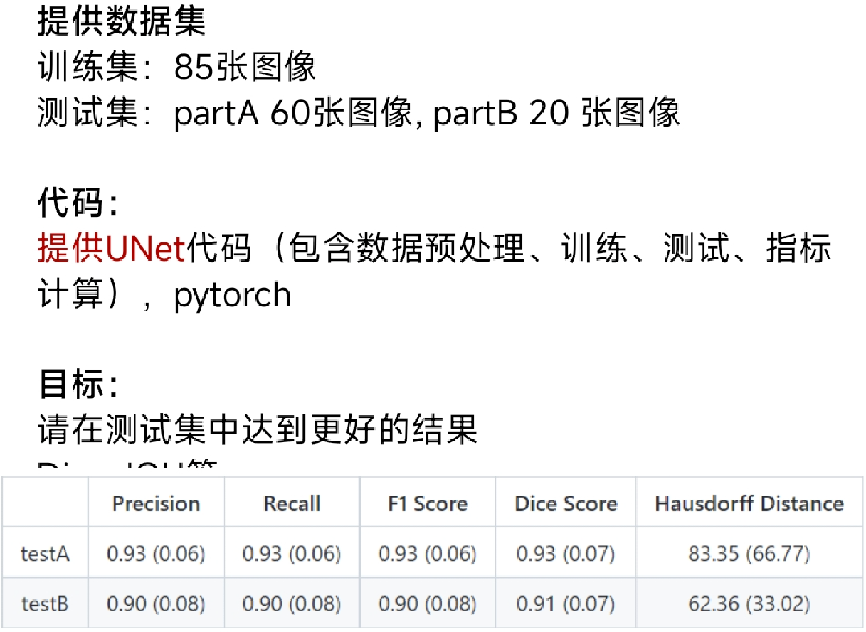

1. **解题步骤（思路+代码）**

import numpy as np   
import pandas as pd   
import matplotlib.pyplot as plt   
import seaborn as sns   
import cv2  
import os   
import utils

This notebook attempts to explore the data set through data analysis, preprocess the image and build input pipeline for model training

# Data Understanding

df = pd.read_csv('Grade.csv')  
print(df.head())

name patient ID grade (GlaS) grade (Sirinukunwattana et al. 2015)  
0 testA_1 4 benign adenomatous  
1 testA_10 10 benign healthy  
2 testA_11 9 benign healthy  
3 testA_12 11 malignant poorly differentiated  
4 testA_13 7 malignant moderately differentiated

print("Number of images: ", df.shape[0])

Number of images: 165

img_dir = 'glas_dataset/'  
img_path = sorted((os.listdir(img_dir)))  
print(img_path)

['testA_1.bmp', 'testA_10.bmp', 'testA_10_anno.bmp', 'testA_11.bmp', 'testA_11_anno.bmp', 'testA_12.bmp', 'testA_12_anno.bmp', 'testA_13.bmp', 'testA_13_anno.bmp', 'testA_14.bmp', 'testA_14_anno.bmp', 'testA_15.bmp', 'testA_15_anno.bmp', 'testA_16.bmp', 'testA_16_anno.bmp', 'testA_17.bmp', 'testA_17_anno.bmp', 'testA_18.bmp', 'testA_18_anno.bmp', 'testA_19.bmp', 'testA_19_anno.bmp', 'testA_1_anno.bmp', 'testA_2.bmp', 'testA_20.bmp', 'testA_20_anno.bmp', 'testA_21.bmp', 'testA_21_anno.bmp', 'testA_22.bmp', 'testA_22_anno.bmp', 'testA_23.bmp', 'testA_23_anno.bmp', 'testA_24.bmp', 'testA_24_anno.bmp', 'testA_25.bmp', 'testA_25_anno.bmp', 'testA_26.bmp', 'testA_26_anno.bmp', 'testA_27.bmp', 'testA_27_anno.bmp', 'testA_28.bmp', 'testA_28_anno.bmp', 'testA_29.bmp', 'testA_29_anno.bmp', 'testA_2_anno.bmp', 'testA_3.bmp', 'testA_30.bmp', 'testA_30_anno.bmp', 'testA_31.bmp', 'testA_31_anno.bmp', 'testA_32.bmp', 'testA_32_anno.bmp', 'testA_33.bmp', 'testA_33_anno.bmp', 'testA_34.bmp', 'testA_34_anno.bmp', 'testA_35.bmp', 'testA_35_anno.bmp', 'testA_36.bmp', 'testA_36_anno.bmp', 'testA_37.bmp', 'testA_37_anno.bmp', 'testA_38.bmp', 'testA_38_anno.bmp', 'testA_39.bmp', 'testA_39_anno.bmp', 'testA_3_anno.bmp', 'testA_4.bmp', 'testA_40.bmp', 'testA_40_anno.bmp', 'testA_41.bmp', 'testA_41_anno.bmp', 'testA_42.bmp', 'testA_42_anno.bmp', 'testA_43.bmp', 'testA_43_anno.bmp', 'testA_44.bmp', 'testA_44_anno.bmp', 'testA_45.bmp', 'testA_45_anno.bmp', 'testA_46.bmp', 'testA_46_anno.bmp', 'testA_47.bmp', 'testA_47_anno.bmp', 'testA_48.bmp', 'testA_48_anno.bmp', 'testA_49.bmp', 'testA_49_anno.bmp', 'testA_4_anno.bmp', 'testA_5.bmp', 'testA_50.bmp', 'testA_50_anno.bmp', 'testA_51.bmp', 'testA_51_anno.bmp', 'testA_52.bmp', 'testA_52_anno.bmp', 'testA_53.bmp', 'testA_53_anno.bmp', 'testA_54.bmp', 'testA_54_anno.bmp', 'testA_55.bmp', 'testA_55_anno.bmp', 'testA_56.bmp', 'testA_56_anno.bmp', 'testA_57.bmp', 'testA_57_anno.bmp', 'testA_58.bmp', 'testA_58_anno.bmp', 'testA_59.bmp', 'testA_59_anno.bmp', 'testA_5_anno.bmp', 'testA_6.bmp', 'testA_60.bmp', 'testA_60_anno.bmp', 'testA_6_anno.bmp', 'testA_7.bmp', 'testA_7_anno.bmp', 'testA_8.bmp', 'testA_8_anno.bmp', 'testA_9.bmp', 'testA_9_anno.bmp', 'testB_1.bmp', 'testB_10.bmp', 'testB_10_anno.bmp', 'testB_11.bmp', 'testB_11_anno.bmp', 'testB_12.bmp', 'testB_12_anno.bmp', 'testB_13.bmp', 'testB_13_anno.bmp', 'testB_14.bmp', 'testB_14_anno.bmp', 'testB_15.bmp', 'testB_15_anno.bmp', 'testB_16.bmp', 'testB_16_anno.bmp', 'testB_17.bmp', 'testB_17_anno.bmp', 'testB_18.bmp', 'testB_18_anno.bmp', 'testB_19.bmp', 'testB_19_anno.bmp', 'testB_1_anno.bmp', 'testB_2.bmp', 'testB_20.bmp', 'testB_20_anno.bmp', 'testB_2_anno.bmp', 'testB_3.bmp', 'testB_3_anno.bmp', 'testB_4.bmp', 'testB_4_anno.bmp', 'testB_5.bmp', 'testB_5_anno.bmp', 'testB_6.bmp', 'testB_6_anno.bmp', 'testB_7.bmp', 'testB_7_anno.bmp', 'testB_8.bmp', 'testB_8_anno.bmp', 'testB_9.bmp', 'testB_9_anno.bmp', 'train_1.bmp', 'train_10.bmp', 'train_10_anno.bmp', 'train_11.bmp', 'train_11_anno.bmp', 'train_12.bmp', 'train_12_anno.bmp', 'train_13.bmp', 'train_13_anno.bmp', 'train_14.bmp', 'train_14_anno.bmp', 'train_15.bmp', 'train_15_anno.bmp', 'train_16.bmp', 'train_16_anno.bmp', 'train_17.bmp', 'train_17_anno.bmp', 'train_18.bmp', 'train_18_anno.bmp', 'train_19.bmp', 'train_19_anno.bmp', 'train_1_anno.bmp', 'train_2.bmp', 'train_20.bmp', 'train_20_anno.bmp', 'train_21.bmp', 'train_21_anno.bmp', 'train_22.bmp', 'train_22_anno.bmp', 'train_23.bmp', 'train_23_anno.bmp', 'train_24.bmp', 'train_24_anno.bmp', 'train_25.bmp', 'train_25_anno.bmp', 'train_26.bmp', 'train_26_anno.bmp', 'train_27.bmp', 'train_27_anno.bmp', 'train_28.bmp', 'train_28_anno.bmp', 'train_29.bmp', 'train_29_anno.bmp', 'train_2_anno.bmp', 'train_3.bmp', 'train_30.bmp', 'train_30_anno.bmp', 'train_31.bmp', 'train_31_anno.bmp', 'train_32.bmp', 'train_32_anno.bmp', 'train_33.bmp', 'train_33_anno.bmp', 'train_34.bmp', 'train_34_anno.bmp', 'train_35.bmp', 'train_35_anno.bmp', 'train_36.bmp', 'train_36_anno.bmp', 'train_37.bmp', 'train_37_anno.bmp', 'train_38.bmp', 'train_38_anno.bmp', 'train_39.bmp', 'train_39_anno.bmp', 'train_3_anno.bmp', 'train_4.bmp', 'train_40.bmp', 'train_40_anno.bmp', 'train_41.bmp', 'train_41_anno.bmp', 'train_42.bmp', 'train_42_anno.bmp', 'train_43.bmp', 'train_43_anno.bmp', 'train_44.bmp', 'train_44_anno.bmp', 'train_45.bmp', 'train_45_anno.bmp', 'train_46.bmp', 'train_46_anno.bmp', 'train_47.bmp', 'train_47_anno.bmp', 'train_48.bmp', 'train_48_anno.bmp', 'train_49.bmp', 'train_49_anno.bmp', 'train_4_anno.bmp', 'train_5.bmp', 'train_50.bmp', 'train_50_anno.bmp', 'train_51.bmp', 'train_51_anno.bmp', 'train_52.bmp', 'train_52_anno.bmp', 'train_53.bmp', 'train_53_anno.bmp', 'train_54.bmp', 'train_54_anno.bmp', 'train_55.bmp', 'train_55_anno.bmp', 'train_56.bmp', 'train_56_anno.bmp', 'train_57.bmp', 'train_57_anno.bmp', 'train_58.bmp', 'train_58_anno.bmp', 'train_59.bmp', 'train_59_anno.bmp', 'train_5_anno.bmp', 'train_6.bmp', 'train_60.bmp', 'train_60_anno.bmp', 'train_61.bmp', 'train_61_anno.bmp', 'train_62.bmp', 'train_62_anno.bmp', 'train_63.bmp', 'train_63_anno.bmp', 'train_64.bmp', 'train_64_anno.bmp', 'train_65.bmp', 'train_65_anno.bmp', 'train_66.bmp', 'train_66_anno.bmp', 'train_67.bmp', 'train_67_anno.bmp', 'train_68.bmp', 'train_68_anno.bmp', 'train_69.bmp', 'train_69_anno.bmp', 'train_6_anno.bmp', 'train_7.bmp', 'train_70.bmp', 'train_70_anno.bmp', 'train_71.bmp', 'train_71_anno.bmp', 'train_72.bmp', 'train_72_anno.bmp', 'train_73.bmp', 'train_73_anno.bmp', 'train_74.bmp', 'train_74_anno.bmp', 'train_75.bmp', 'train_75_anno.bmp', 'train_76.bmp', 'train_76_anno.bmp', 'train_77.bmp', 'train_77_anno.bmp', 'train_78.bmp', 'train_78_anno.bmp', 'train_79.bmp', 'train_79_anno.bmp', 'train_7_anno.bmp', 'train_8.bmp', 'train_80.bmp', 'train_80_anno.bmp', 'train_81.bmp', 'train_81_anno.bmp', 'train_82.bmp', 'train_82_anno.bmp', 'train_83.bmp', 'train_83_anno.bmp', 'train_84.bmp', 'train_84_anno.bmp', 'train_85.bmp', 'train_85_anno.bmp', 'train_8_anno.bmp', 'train_9.bmp', 'train_9_anno.bmp']

From the data set directory above, we can observed that there is 3 main category, which is "train", "testA" and "testB", with each images in the category associated with one annotated file which is the pixel-wise annotation for segmentation

Assign fold number to each image category for easy dataloading, such that:

* 'train' image => fold 0
* 'testA' image => fold 1
* 'testB' image => fold 2

fold = []  
for name in df['name'].tolist():  
 # split the name with '_'   
 candidate = name.split('_')  
 # 'train' => 0  
 if candidate[0] == 'train':  
 fold.append(0)  
 # 'testA' => 1  
 if candidate[0] == 'testA':  
 fold.append(1)  
 # 'testB' => 2  
 if candidate[0] == 'testB':  
 fold.append(2)  
df['fold'] = fold   
print(df)

name patient ID grade (GlaS) grade (Sirinukunwattana et al. 2015) \  
0 testA_1 4 benign adenomatous   
1 testA_10 10 benign healthy   
2 testA_11 9 benign healthy   
3 testA_12 11 malignant poorly differentiated   
4 testA_13 7 malignant moderately differentiated   
.. ... ... ... ...   
160 train_82 2 malignant moderately-to-poorly differentated   
161 train_83 11 malignant poorly differentiated   
162 train_84 15 benign healthy   
163 train_85 10 benign healthy   
164 train_9 10 benign healthy   
  
 fold   
0 1   
1 1   
2 1   
3 1   
4 1   
.. ...   
160 0   
161 0   
162 0   
163 0   
164 0   
  
[165 rows x 5 columns]

# image category index   
train_idx = np.where(df['fold'] == 0)[0]  
testA_idx = np.where(df['fold'] == 1)[0]  
testB_idx = np.where(df['fold'] == 2)[0]

### Distribution of Train and Test set

fig = plt.figure()  
ax = fig.add_axes([0,0,1,1])  
fold = ['train', 'testA', 'testB']  
n_img = [train_idx.shape[0], testA_idx.shape[0], testB_idx.shape[0]]  
ax.bar(fold,n_img)  
plt.show()

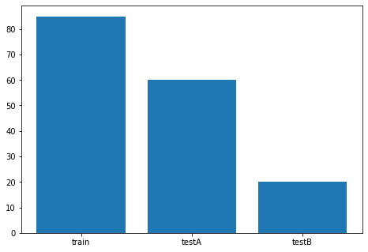

print('Number of train dataset:', train_idx.shape[0])  
print('Number of testA dataset:', testA_idx.shape[0])  
print('Number of testB dataset:', testB_idx.shape[0])

Number of train dataset: 85  
Number of testA dataset: 60  
Number of testB dataset: 20

### Distribution of Malignant and Benign class in train and test set

def unique_fn(x, idx):  
 '''  
 helper function to return the unique val counts   
 through index retrieval of the list  
 '''  
 return np.unique(np.take(x, idx), return_counts=True)  
  
train_val, train_count = unique_fn(df[' grade (GlaS)'], train_idx)  
testA_val, testA_count = unique_fn(df[' grade (GlaS)'], testA_idx)  
testB_val, testB_count = unique_fn(df[' grade (GlaS)'], testB_idx)

# set width of bar  
barWidth = 0.25  
fig = plt.subplots(figsize =(10, 6))  
   
# set height of bar  
data = np.stack([train_count, testA_count, testB_count]).T   
   
# Set position of bar on X axis  
br1 = np.arange(3)  
br2 = [x + barWidth for x in br1]  
   
# Make the plot  
plt.bar(br1, data[0], color ='g', width = barWidth,  
 edgecolor ='grey', label ='Benign')  
plt.bar(br2, data[1], color ='b', width = barWidth,  
 edgecolor ='grey', label ='Malignant')  
   
# Adding Xticks  
plt.xlabel('Dataset', fontweight ='bold', fontsize = 15)  
plt.ylabel('Image Number', fontweight ='bold', fontsize = 15)  
plt.xticks([r + barWidth for r in range(3)],  
 ['train', 'testA', 'testB'], fontsize = 15)  
   
plt.legend()  
plt.show()

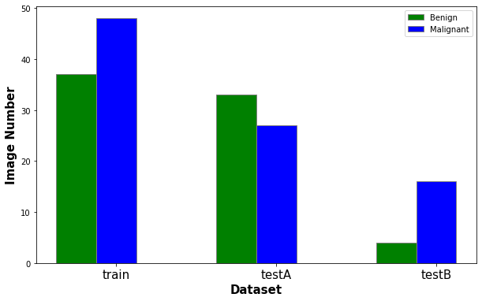

print('Train image, benign: {}, malignant: {}'.format(train_count[0], train_count[1]))  
print('TestA image, benign: {}, malignant: {}'.format(testA_count[0], testA_count[1]))  
print('TestB image, benign: {}, malignant: {}'.format(testB_count[0], testB_count[1]))

Train image, benign: 37, malignant: 48  
TestA image, benign: 33, malignant: 27  
TestB image, benign: 4, malignant: 16

### Image dataset width and height

# add image width and height into the dataframe   
df['image_height'] = [cv2.imread(w).shape[0] for w in img_dir+df['name']+'.bmp']  
df['image_width'] = [cv2.imread(w).shape[1] for w in img_dir+df['name']+'.bmp']

val, count = np.unique(df['image_width'], return_counts=True)  
print('Image width: ', val)  
print('Count: ', count)  
print()  
df['image_width'].describe()

Image width: [567 574 578 581 589 775]  
Count: [ 1 2 1 2 8 151]

count 165.000000  
mean 758.739394  
std 53.606959  
min 567.000000  
25% 775.000000  
50% 775.000000  
75% 775.000000  
max 775.000000  
Name: image_width, dtype: float64

val, count = np.unique(df['image_height'], return_counts=True)  
print('Image height: ', val)  
print('Count: ', count)  
print()  
df['image_height'].describe()

Image height: [430 433 442 453 522]  
Count: [ 1 3 2 8 151]

count 165.000000  
mean 515.509091  
std 21.550173  
min 430.000000  
25% 522.000000  
50% 522.000000  
75% 522.000000  
max 522.000000  
Name: image_height, dtype: float64

From the above analyses it is observed that the image size consisted of:

* Width range: 567~775
* Height range: 430~522

However, most of the image falls under the size of (775x522)

### Image Pixel Check

# sample an image for checking   
tmp_img = cv2.imread(img_dir+'testA_1.bmp')  
tmp_anno = cv2.imread(img_dir+'testA_1_anno.bmp')  
print('Image Max pixel value: {}, Min pixel value: {}'.format(np.max(tmp_img), np.min(tmp_img)))  
print('Image Max pixel value: {}, Min pixel value: {}'.format(np.max(tmp_anno), np.min(tmp_anno)))

Image Max pixel value: 255, Min pixel value: 16  
Image Max pixel value: 9, Min pixel value: 0

The pixel value for the images falls between [0, 255] and for annotation images, we have gland wise labelling

max_ = []  
# find the maximum number of glands can an image have   
for name in img_path:  
 # split the name with '_'   
 candidate = name.split('_')  
 if candidate[-1] != 'anno.bmp':  
 continue  
 else:  
 img_anno = cv2.imread(img_dir+name)  
 max_.append(np.max(img_anno))  
print("The maximum number of glands in an image is: ", np.max(max_))

The maximum number of glands in an image is: 32

# cast annotated image segmentation to only foreground and background  
tmp_anno_thres = np.where(tmp_anno>0, 1.0, 0.0)  
# gland level masking  
gland_mask = utils.plot_labels_color(tmp_anno, cmap='Pastel1')  
# super imposed annotated image masking with boundary on glands  
overlay_img = utils.overlay_boundary(utils.overlay_mask(tmp_img, tmp_anno_thres, alpha=0.1),   
 tmp_anno_thres)  
imgs = [tmp_img, gland_mask, tmp_anno_thres, overlay_img]  
captions = ['Original', 'Glands Mask', 'Masking', 'Overlay']  
utils.plot_comparison(imgs, captions, n_col=len(imgs),   
 figsize=(12,12), cmap=None)

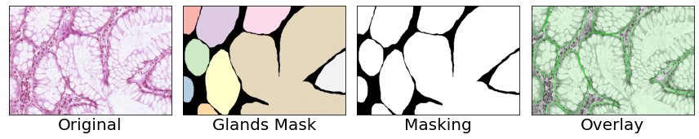

# Data Preprocessing

In this section, the following process will be carried out:

* The images will be resize to (512, 512) with bilinear interpolation
* All images will be stored in .npy format for better data-loading.

Image normalization and annotated image binarization can be done on the fly

# intuitively resize to size with power of 2 for easier downsampling   
new_size = (512, 512)  
# save directory   
save_dir = 'img_npy/'  
img_save_path_list = []  
anno_save_path_list = []  
if not os.path.exists(save_dir):  
 os.makedirs(save_dir)  
for name in df['name']:  
 gland_img = cv2.imread(img_dir+name+'.bmp').astype('float32')  
 # resize image   
 gland_img = cv2.resize(gland_img, new_size)  
 gland_img_save_path = save_dir+name+'.npy'  
 np.save(gland_img_save_path, gland_img)  
 img_save_path_list.append(gland_img_save_path)  
 # -----------------------------------------  
 gland_img_anno = cv2.imread(img_dir+name+'_anno.bmp').astype('float32')  
 # resize anno  
 gland_img_anno = cv2.resize(gland_img_anno, new_size)  
 gland_img_anno_save_path = save_dir+name+'_anno.npy'  
 np.save(gland_img_anno_save_path, gland_img_anno)  
 anno_save_path_list.append(gland_img_anno_save_path)

# save .npy path list for image and image annotations into dataframe  
df['img_npy'] = img_save_path_list  
df['anno_npy'] = anno_save_path_list  
print(df.head())

name patient ID grade (GlaS) grade (Sirinukunwattana et al. 2015) \  
0 testA_1 4 benign adenomatous   
1 testA_10 10 benign healthy   
2 testA_11 9 benign healthy   
3 testA_12 11 malignant poorly differentiated   
4 testA_13 7 malignant moderately differentiated   
  
 fold image_height image_width img_npy \  
0 1 522 775 img_npy/testA_1.npy   
1 1 522 775 img_npy/testA_10.npy   
2 1 522 775 img_npy/testA_11.npy   
3 1 522 775 img_npy/testA_12.npy   
4 1 522 775 img_npy/testA_13.npy   
  
 anno_npy   
0 img_npy/testA_1_anno.npy   
1 img_npy/testA_10_anno.npy   
2 img_npy/testA_11_anno.npy   
3 img_npy/testA_12_anno.npy   
4 img_npy/testA_13_anno.npy

# save modified data frame into new csv file  
df.to_csv('data.csv', index=False)  
ds = pd.read_csv('data.csv')  
print(ds)

name patient ID grade (GlaS) grade (Sirinukunwattana et al. 2015) \  
0 testA_1 4 benign adenomatous   
1 testA_10 10 benign healthy   
2 testA_11 9 benign healthy   
3 testA_12 11 malignant poorly differentiated   
4 testA_13 7 malignant moderately differentiated   
.. ... ... ... ...   
160 train_82 2 malignant moderately-to-poorly differentated   
161 train_83 11 malignant poorly differentiated   
162 train_84 15 benign healthy   
163 train_85 10 benign healthy   
164 train_9 10 benign healthy   
  
 fold image_height image_width img_npy \  
0 1 522 775 img_npy/testA_1.npy   
1 1 522 775 img_npy/testA_10.npy   
2 1 522 775 img_npy/testA_11.npy   
3 1 522 775 img_npy/testA_12.npy   
4 1 522 775 img_npy/testA_13.npy   
.. ... ... ... ...   
160 0 522 775 img_npy/train_82.npy   
161 0 522 775 img_npy/train_83.npy   
162 0 453 589 img_npy/train_84.npy   
163 0 522 775 img_npy/train_85.npy   
164 0 522 775 img_npy/train_9.npy   
  
 anno_npy   
0 img_npy/testA_1_anno.npy   
1 img_npy/testA_10_anno.npy   
2 img_npy/testA_11_anno.npy   
3 img_npy/testA_12_anno.npy   
4 img_npy/testA_13_anno.npy   
.. ...   
160 img_npy/train_82_anno.npy   
161 img_npy/train_83_anno.npy   
162 img_npy/train_84_anno.npy   
163 img_npy/train_85_anno.npy   
164 img_npy/train_9_anno.npy   
  
[165 rows x 9 columns]

import numpy as np   
import matplotlib.pyplot as plt   
import utils  
import dataloader  
import pandas as pd  
from batchgenerators.dataloading.multi_threaded_augmenter import MultiThreadedAugmenter

tabular_data = pd.read_csv('data.csv')  
ds_dict = dataloader.get_split_fold(tabular_data)

'train', 'testA' and 'testB' dataset are stored in the ds_dict, this work, testA is treated as validatin data set for hyperparameter tuning and testB is treated as the test set.

ds_dict.keys()

dict_keys(['train_ds', 'testA_ds', 'testB_ds'])

With each data sets containing the dictionary that stored the paths to gland image, annotated image and also the patient id.

ds_dict['train_ds'].keys()

dict_keys(['img_npy', 'anno_npy', 'patient_id'])

# Data loading and Data Augmentation

## Training Data Loading Pipeline

In this work I adopted the data augmentation framework for medical images by MIC-DKFZ. The data augmentation adopted here is elastic transformation. rotation, image scaling, mirror transformation, brightness transformation, gaussian noise injection, gaussian blur transformation and contrast augmentation with a probability of 0.5.

patch_size = (512, 512)  
batch_size = 8  
tr_transforms = dataloader.get_train_transform(patch_size)  
train_dl = dataloader.DataLoader(data=ds_dict['train_ds'], batch_size=batch_size, patch_size=patch_size,  
 num_threads_in_multithreaded=4, seed_for_shuffle=5243,  
 return_incomplete=False, shuffle=True, infinite=True)  
train_gen = MultiThreadedAugmenter(train_dl, tr_transforms, num_processes=4,  
 num_cached_per_queue=2,  
 seeds=None, pin_memory=False)

# sanity check for data augmentation techniques for training data set  
for i in range(5):  
 train_batch = next(train_gen)  
 imgs = train_batch['data']  
 segs = train_batch['seg']  
 patient_id = train_batch['patient_id']  
 # tensor manipulation: channel first -> channel last  
 imgs = np.einsum('bchw->bhwc', imgs)  
 segs = np.einsum('bchw->bhwc', segs)  
 # normalization  
 imgs = utils.min_max_norm(imgs)  
 # binarisation   
 segs = np.where(segs>0., 1.0, 0.).astype('float32')  
 print('-'*100)  
 print("Batch no.:", i)  
 print("Gland Image dimension:", imgs.shape)  
 imgs_list = [imgs[i] for i in range(5)]  
 print("Gland Image dimension:", segs.shape)  
 segs_list = [segs[i] for i in range(5)]  
 captions = ['patient_id: {}'.format(patient_id[i]) for i in range(5)]  
 utils.plot_comparison(imgs_list, captions, n_col=len(imgs_list),   
 figsize=(15,15), cmap=None)  
 utils.plot_comparison(segs_list, captions, n_col=len(imgs_list),   
 figsize=(15,15), cmap=None)

----------------------------------------------------------------------------------------------------  
Batch no.: 0  
Gland Image dimension: (8, 512, 512, 3)  
Gland Image dimension: (8, 512, 512, 3)

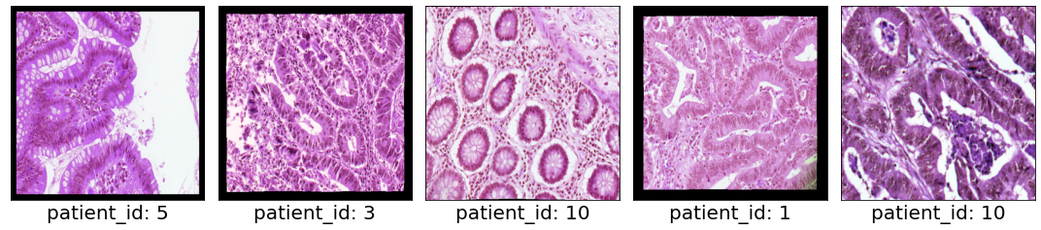

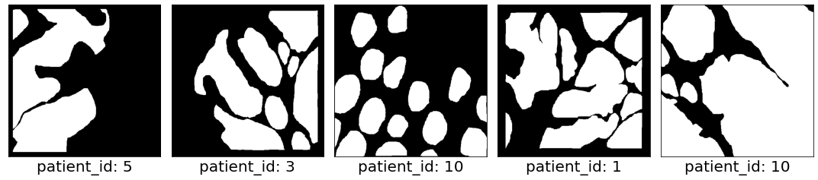

----------------------------------------------------------------------------------------------------  
Batch no.: 1  
Gland Image dimension: (8, 512, 512, 3)  
Gland Image dimension: (8, 512, 512, 3)

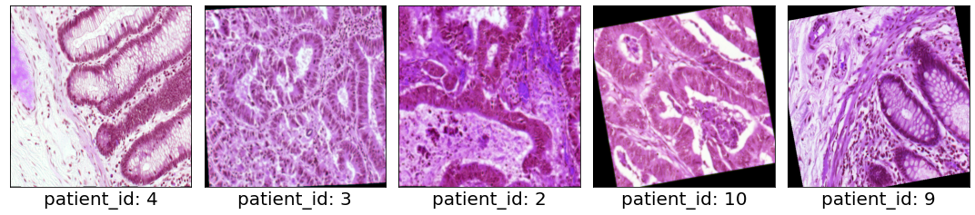

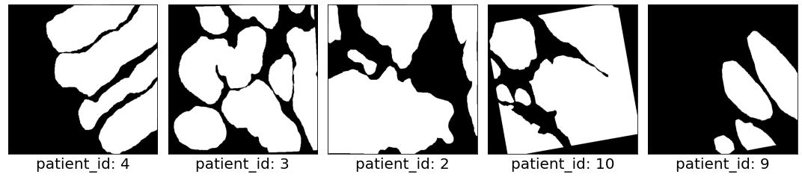

----------------------------------------------------------------------------------------------------  
Batch no.: 2  
Gland Image dimension: (8, 512, 512, 3)  
Gland Image dimension: (8, 512, 512, 3)

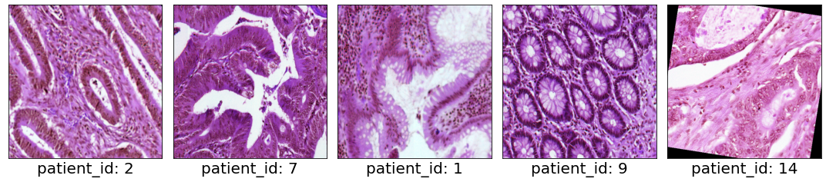

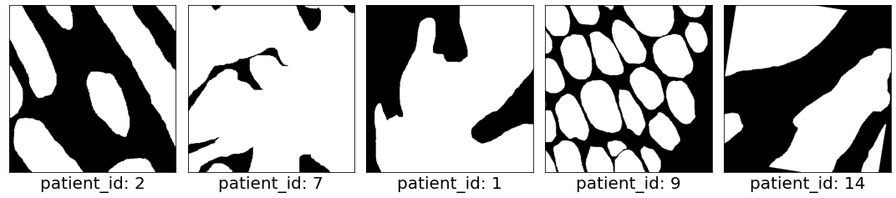

----------------------------------------------------------------------------------------------------  
Batch no.: 3  
Gland Image dimension: (8, 512, 512, 3)  
Gland Image dimension: (8, 512, 512, 3)

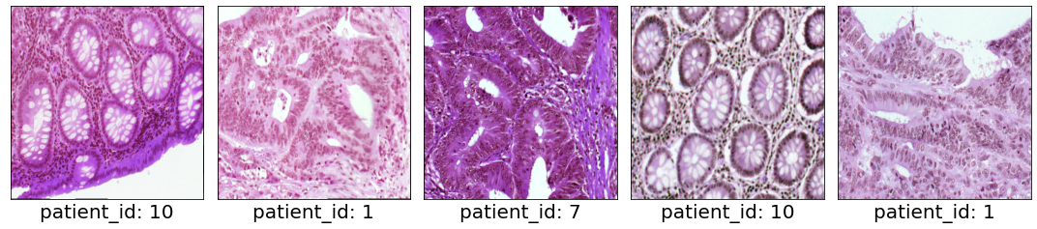

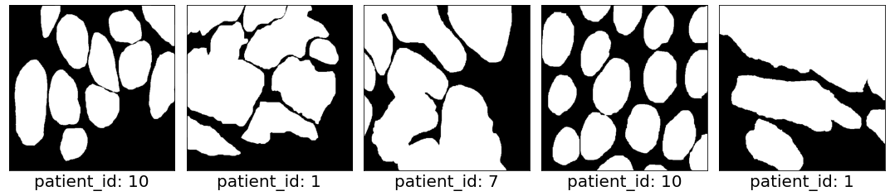

----------------------------------------------------------------------------------------------------  
Batch no.: 4  
Gland Image dimension: (8, 512, 512, 3)  
Gland Image dimension: (8, 512, 512, 3)

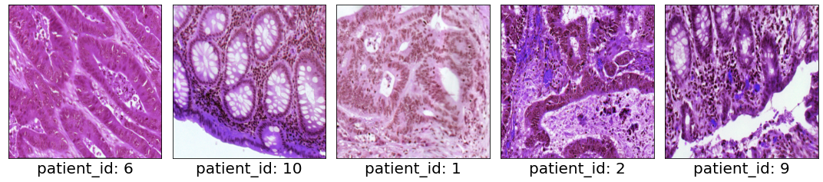

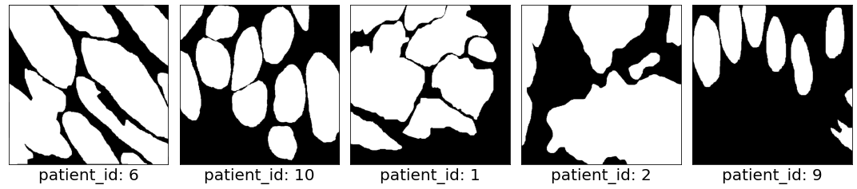

## Validation Data Loading Pipeline

Data augmentation was not adopted for validation and test set

tmp = np.ones((8, 3, 512, 512))  
tmp = np.expand_dims(tmp[:,0,:,:], 1)  
print(tmp.shape)

(8, 1, 512, 512)

val_dl = dataloader.DataLoader(data=ds_dict['testA_ds'], batch_size=batch_size, patch_size=patch_size,  
 num_threads_in_multithreaded=4, seed_for_shuffle=5243,  
 return_incomplete=False, shuffle=True, infinite=True)

# sanity check for validation data pipeline   
for i in range(5):  
 val_batch = next(val_dl)  
 imgs = val_batch['data']  
 segs = val_batch['seg']  
 patient_id = val_batch['patient_id']  
 # tensor manipulation: channel first -> channel last  
 imgs = np.einsum('bchw->bhwc', imgs)  
 segs = np.einsum('bchw->bhwc', segs)  
 # normalization  
 imgs = utils.min_max_norm(imgs)  
 # binarisation   
 segs = np.where(segs>0., 1.0, 0.)  
 print('-'*100)  
 print("Batch no.:", i)  
 print("Gland Image dimension:", imgs.shape)  
 imgs_list = [imgs[i] for i in range(5)]  
 print("Gland Image dimension:", segs.shape)  
 segs_list = [segs[i] for i in range(5)]  
 captions = ['patient_id: {}'.format(patient_id[i]) for i in range(5)]  
 utils.plot_comparison(imgs_list, captions, n_col=len(imgs_list),   
 figsize=(15,15), cmap=None)  
 utils.plot_comparison(segs_list, captions, n_col=len(imgs_list),   
 figsize=(15,15), cmap=None)

----------------------------------------------------------------------------------------------------  
Batch no.: 0  
Gland Image dimension: (8, 512, 512, 3)  
Gland Image dimension: (8, 512, 512, 3)

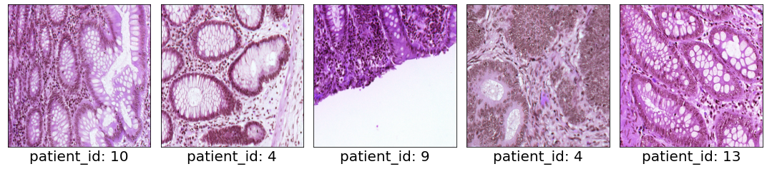

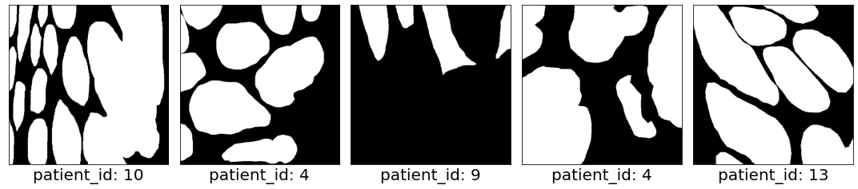

----------------------------------------------------------------------------------------------------  
Batch no.: 1  
Gland Image dimension: (8, 512, 512, 3)  
Gland Image dimension: (8, 512, 512, 3)

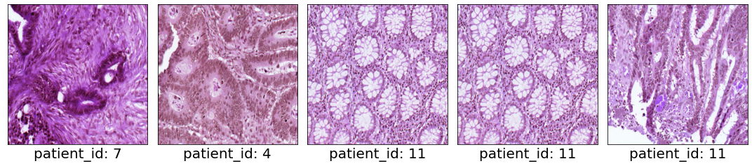

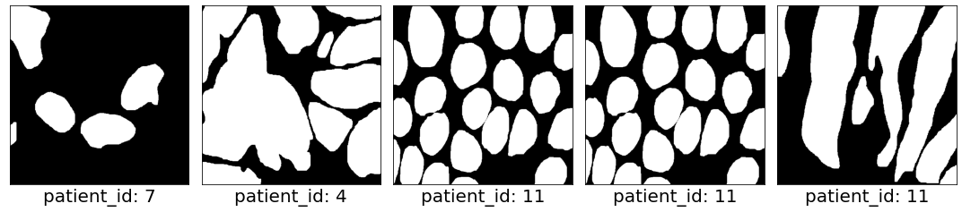

----------------------------------------------------------------------------------------------------  
Batch no.: 2  
Gland Image dimension: (8, 512, 512, 3)  
Gland Image dimension: (8, 512, 512, 3)

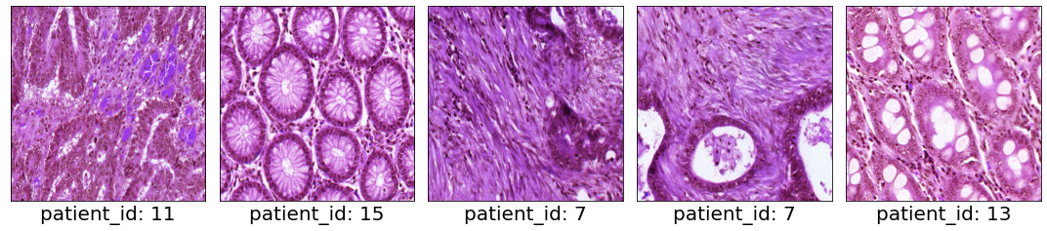

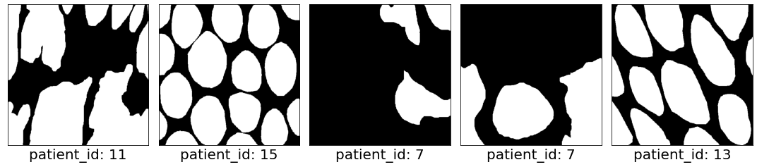

----------------------------------------------------------------------------------------------------  
Batch no.: 3  
Gland Image dimension: (8, 512, 512, 3)  
Gland Image dimension: (8, 512, 512, 3)

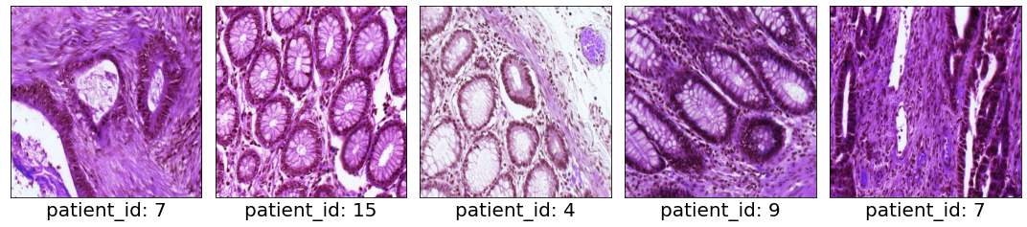

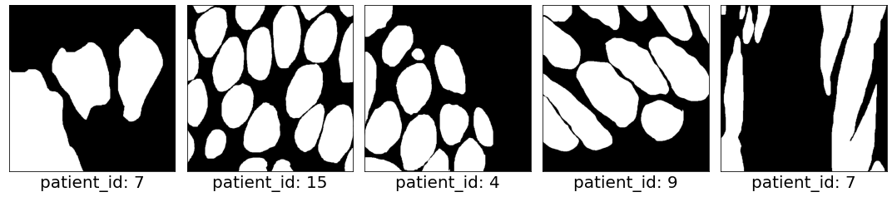

----------------------------------------------------------------------------------------------------  
Batch no.: 4  
Gland Image dimension: (8, 512, 512, 3)  
Gland Image dimension: (8, 512, 512, 3)

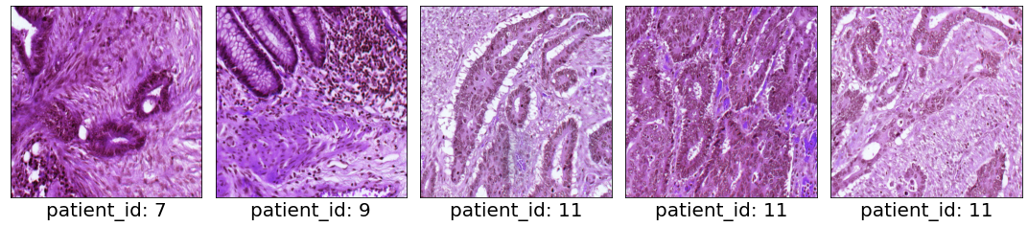

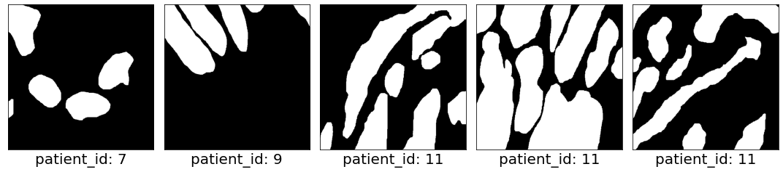

import warnings  
import numpy as np   
import matplotlib.pyplot as plt   
import utils  
import metric   
import torch   
import dataloader   
from batchgenerators.dataloading.multi_threaded_augmenter import MultiThreadedAugmenter  
import segmentation_models_pytorch as smp  
from torchsummary import summary  
import time  
import math   
import pandas as pd   
import wandb  
from tqdm import tqdm  
from torch import nn  
from sklearn.metrics import precision_recall_fscore_support, jaccard_score  
from scipy.spatial.distance import directed_hausdorff  
from matplotlib.lines import Line2D  
import seaborn as sns  
%matplotlib inline

# Hyperparameters

Hyperparameter tuning with wandb sweep techniques, using grid search. The hyperparameters tuned are as below:

* batch size: [4, 8, 16]
* learning rate: [1e-2, 1e-3, le-4, 1e-5]
* encoder model: [resnet18, resnet34, resnet50]

plt.figure(figsize=(15, 8))  
plt.imshow(np.array(plt.imread('fig/hyperparam_tuning.png')))

<matplotlib.image.AxesImage at 0x7efb8b11f390>

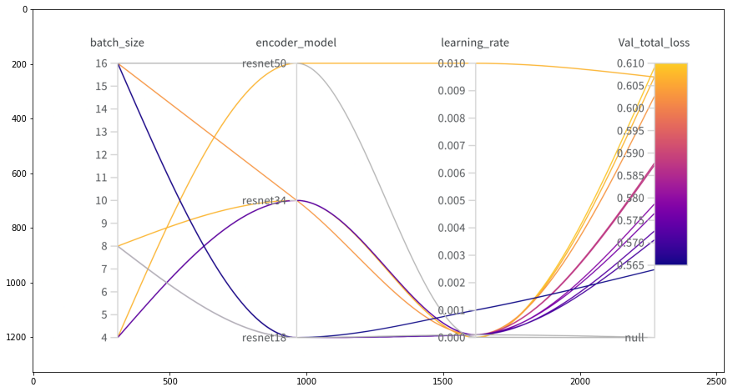

Best hyperparameter:

* batch size: 16
* encoder model: resnet 18
* learning rate: 0.001

For learning rate scheduling, I adapted reduce learning rate on plataeu with patience of 20.

plt.figure(figsize=(10, 8))  
plt.imshow(np.array(plt.imread('fig/learning_rate.png')))

<matplotlib.image.AxesImage at 0x7efb87cd0d30>

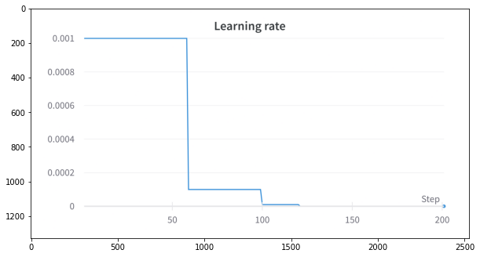

plt.figure(figsize=(10, 8))  
plt.imshow(np.array(plt.imread('fig/total_loss_plot.png')))

<matplotlib.image.AxesImage at 0x7efb8490d2e8>

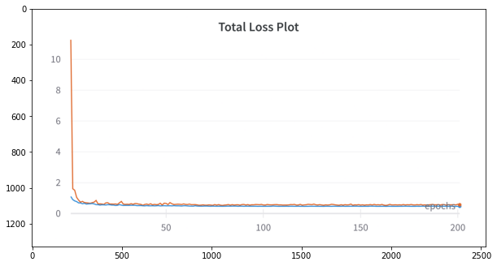

# load hyperparams  
batch_size = 16  
patch_size = (512, 512)  
encoder_model = 'resnet18'  
n_class = 1  
test_fol = 'testB_ds'  
weight_path = 'weights/best_weight.pth'

# Model Building

warnings.filterwarnings('ignore')  
tabular_data = pd.read_csv('data.csv')  
ds_dict = dataloader.get_split_fold(tabular_data)  
val_dl = dataloader.DataLoader(data=ds_dict[test_fol], batch_size=batch_size, patch_size=patch_size,  
 num_threads_in_multithreaded=1, seed_for_shuffle=5243,  
 return_incomplete=True, shuffle=False, infinite=False)  
# Get cpu or gpu device for training  
device = "cuda" if torch.cuda.is_available() else "cpu"  
# define model  
model = smp.Unet(encoder_name=encoder_model, decoder_use_batchnorm=True,  
 in_channels=3, classes=n_class).to(device)

The model choice is UNet architecture with trainable parameters of around 14 million.

summary(model, (3, 512, 512))

==========================================================================================  
Layer (type:depth-idx) Output Shape Param #  
==========================================================================================  
├─ResNetEncoder: 1-1 [-1, 3, 512, 512] --  
| └─Conv2d: 2-1 [-1, 64, 256, 256] 9,408  
| └─BatchNorm2d: 2-2 [-1, 64, 256, 256] 128  
| └─ReLU: 2-3 [-1, 64, 256, 256] --  
| └─MaxPool2d: 2-4 [-1, 64, 128, 128] --  
| └─Sequential: 2-5 [-1, 64, 128, 128] --  
| | └─BasicBlock: 3-1 [-1, 64, 128, 128] 73,984  
| | └─BasicBlock: 3-2 [-1, 64, 128, 128] 73,984  
| └─Sequential: 2-6 [-1, 128, 64, 64] --  
| | └─BasicBlock: 3-3 [-1, 128, 64, 64] 230,144  
| | └─BasicBlock: 3-4 [-1, 128, 64, 64] 295,424  
| └─Sequential: 2-7 [-1, 256, 32, 32] --  
| | └─BasicBlock: 3-5 [-1, 256, 32, 32] 919,040  
| | └─BasicBlock: 3-6 [-1, 256, 32, 32] 1,180,672  
| └─Sequential: 2-8 [-1, 512, 16, 16] --  
| | └─BasicBlock: 3-7 [-1, 512, 16, 16] 3,673,088  
| | └─BasicBlock: 3-8 [-1, 512, 16, 16] 4,720,640  
├─UnetDecoder: 1-2 [-1, 16, 512, 512] --  
| └─Identity: 2-9 [-1, 512, 16, 16] --  
| └─ModuleList: 2 [] --  
| | └─DecoderBlock: 3-9 [-1, 256, 32, 32] 2,360,320  
| | └─DecoderBlock: 3-10 [-1, 128, 64, 64] 590,336  
| | └─DecoderBlock: 3-11 [-1, 64, 128, 128] 147,712  
| | └─DecoderBlock: 3-12 [-1, 32, 256, 256] 46,208  
| | └─DecoderBlock: 3-13 [-1, 16, 512, 512] 6,976  
├─SegmentationHead: 1-3 [-1, 1, 512, 512] --  
| └─Conv2d: 2-10 [-1, 1, 512, 512] 145  
| └─Identity: 2-11 [-1, 1, 512, 512] --  
| └─Activation: 2-12 [-1, 1, 512, 512] --  
| | └─Identity: 3-14 [-1, 1, 512, 512] --  
==========================================================================================  
Total params: 14,328,209  
Trainable params: 14,328,209  
Non-trainable params: 0  
Total mult-adds (G): 9.46  
==========================================================================================  
Input size (MB): 3.00  
Forward/backward pass size (MB): 186.00  
Params size (MB): 54.66  
Estimated Total Size (MB): 243.66  
==========================================================================================

==========================================================================================  
Layer (type:depth-idx) Output Shape Param #  
==========================================================================================  
├─ResNetEncoder: 1-1 [-1, 3, 512, 512] --  
| └─Conv2d: 2-1 [-1, 64, 256, 256] 9,408  
| └─BatchNorm2d: 2-2 [-1, 64, 256, 256] 128  
| └─ReLU: 2-3 [-1, 64, 256, 256] --  
| └─MaxPool2d: 2-4 [-1, 64, 128, 128] --  
| └─Sequential: 2-5 [-1, 64, 128, 128] --  
| | └─BasicBlock: 3-1 [-1, 64, 128, 128] 73,984  
| | └─BasicBlock: 3-2 [-1, 64, 128, 128] 73,984  
| └─Sequential: 2-6 [-1, 128, 64, 64] --  
| | └─BasicBlock: 3-3 [-1, 128, 64, 64] 230,144  
| | └─BasicBlock: 3-4 [-1, 128, 64, 64] 295,424  
| └─Sequential: 2-7 [-1, 256, 32, 32] --  
| | └─BasicBlock: 3-5 [-1, 256, 32, 32] 919,040  
| | └─BasicBlock: 3-6 [-1, 256, 32, 32] 1,180,672  
| └─Sequential: 2-8 [-1, 512, 16, 16] --  
| | └─BasicBlock: 3-7 [-1, 512, 16, 16] 3,673,088  
| | └─BasicBlock: 3-8 [-1, 512, 16, 16] 4,720,640  
├─UnetDecoder: 1-2 [-1, 16, 512, 512] --  
| └─Identity: 2-9 [-1, 512, 16, 16] --  
| └─ModuleList: 2 [] --  
| | └─DecoderBlock: 3-9 [-1, 256, 32, 32] 2,360,320  
| | └─DecoderBlock: 3-10 [-1, 128, 64, 64] 590,336  
| | └─DecoderBlock: 3-11 [-1, 64, 128, 128] 147,712  
| | └─DecoderBlock: 3-12 [-1, 32, 256, 256] 46,208  
| | └─DecoderBlock: 3-13 [-1, 16, 512, 512] 6,976  
├─SegmentationHead: 1-3 [-1, 1, 512, 512] --  
| └─Conv2d: 2-10 [-1, 1, 512, 512] 145  
| └─Identity: 2-11 [-1, 1, 512, 512] --  
| └─Activation: 2-12 [-1, 1, 512, 512] --  
| | └─Identity: 3-14 [-1, 1, 512, 512] --  
==========================================================================================  
Total params: 14,328,209  
Trainable params: 14,328,209  
Non-trainable params: 0  
Total mult-adds (G): 9.46  
==========================================================================================  
Input size (MB): 3.00  
Forward/backward pass size (MB): 186.00  
Params size (MB): 54.66  
Estimated Total Size (MB): 243.66  
==========================================================================================

# Validation

The loss function used is dice loss and soft binary cross entropy (BCE + label smooting).

# xent = nn.BCELoss()  
dice_loss = smp.losses.DiceLoss(smp.losses.BINARY_MODE, from_logits=True)  
# label smoothing  
xent = smp.losses.SoftBCEWithLogitsLoss(smooth_factor=0.1)  
  
def custom_loss(pred, target):  
 xent_l = xent(pred, target)  
 dice_l = dice_loss(pred, target)  
 loss = xent_l + dice_l  
 return loss, xent_l, dice_l  
  
def test(model):  
 num_batches = math.ceil(len(ds_dict[test_fol]['img_npy']) / batch_size)  
 model.eval()  
 test_loss, correct = 0, 0  
 # no need back prop for testing set  
 batch_xent_l = []  
 batch_dice_l = []  
 batch_loss = []  
 imgs_list = []  
 segs_list = []  
 pred_list = []  
 segs_ori_list = []  
 print("Testing...")  
 with torch.no_grad():  
 for i in tqdm(range(num_batches)):  
 val_batch = next(val_dl)  
 imgs = val_batch['data']  
 segs = val_batch['seg']  
 segs_ori = segs   
 # normalization  
 imgs = utils.min_max_norm(imgs)  
 # binarisation  
 segs = np.where(segs > 0., 1.0, 0.).astype('float32')  
 segs = np.expand_dims(segs[:, 0, :, :], 1)  
 imgs, segs = torch.from_numpy(imgs).to(device), torch.from_numpy(segs).to(device)  
 # Compute loss  
 pred = model(imgs)  
 loss, xent_l, dice_l = custom_loss(pred, segs)  
 # batch losses  
 batch_xent_l.append(xent_l)  
 batch_dice_l.append(dice_l)  
 batch_loss.append(loss)  
 # accumulate outputs for each batch  
 imgs_list.append(imgs.cpu().detach().numpy())  
 segs_list.append(segs.cpu().detach().numpy())  
 pred_list.append(pred.cpu().detach().numpy())  
 segs_ori_list.append(segs_ori)  
 # apply sigmoid to masking  
 segs = nn.Sigmoid()(segs)  
 # taking the average along the batch  
 loss = torch.mean(torch.as_tensor(batch_loss)).item()  
 avg_xent_l = torch.mean(torch.as_tensor(batch_xent_l)).item()  
 avg_dice_l = torch.mean(torch.as_tensor(batch_dice_l)).item()  
 return {'loss': loss, 'xent_l': avg_xent_l, 'dice_l': avg_dice_l,  
 'imgs': imgs_list,  
 'segs': segs_list,  
 'pred': pred_list,  
 'segs_ori': segs_ori_list  
 }

model.load_state_dict(torch.load(weight_path))  
start = time.time()  
test_output = test(model)  
print("Runtime: {} s".format(time.time()-start))  
print("Total loss: {:.2f}, BCE: {:.2f}, Dice Loss: {:2f}".format(test_output['loss'],   
 test_output['xent_l'], test_output['dice_l']))

0%| | 0/2 [00:00<?, ?it/s]

Testing...

100%|██████████| 2/2 [00:00<00:00, 4.68it/s]

Runtime: 0.42966556549072266 s  
Total loss: 0.69, BCE: 0.55, Dice Loss: 0.134812

# channel last for image plotting   
swap = (lambda x: np.einsum('bchw->bhwc', x))  
repeat_channel = (lambda x: np.repeat(x, 3, axis=-1))  
# stack the image along the batch axis   
total_segs = swap(np.vstack(tuple(test_output['segs_ori'])))  
total_imgs = swap(np.vstack(tuple(test_output['imgs'])))  
total_pred = repeat_channel(swap(np.where(np.vstack(tuple(test_output['pred']))>0.5, 1.0, 0.0)))

# sanity check for predicted output   
imgs = [total_imgs[0], total_segs[0], total_pred[0]]  
captions = ['Gland Image', 'Masking', 'Predicted Mask']  
utils.plot_comparison(imgs, captions, n_col=len(imgs), figsize=(12, 12), cmap=None)

Clipping input data to the valid range for imshow with RGB data ([0..1] for floats or [0..255] for integers).

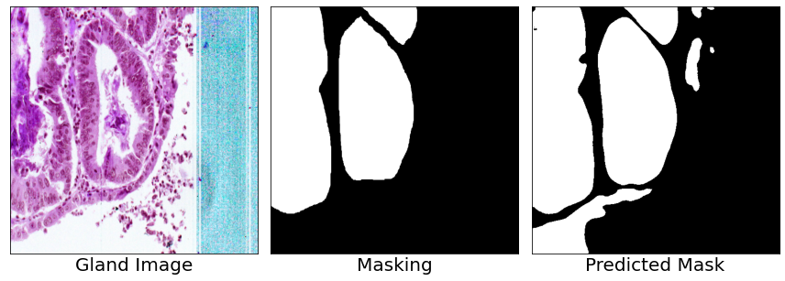

## Results

# Calculate the pixel-wise Precision, Recall, F1-score and Hausdorff Distance  
ori_mask = repeat_channel(swap(np.vstack(tuple(test_output['segs'])))) # binarised masking  
pred_mask = total_pred  
p_list = [] # precision list  
r_list = [] # recall list  
f_list = [] # f1 score list  
hd_list = [] # hausdorff list  
ds_list = [] # dice score list   
for i in range(len(ori_mask)):   
 p, r, f, _ = precision_recall_fscore_support(ori_mask[i][:,:,0].flatten().astype('uint8'),   
 pred_mask[i][:,:,0].flatten().astype('uint8'),  
 average='micro')  
 ds = metric.Dice(ori_mask[i][:,:,0].flatten().astype('uint8'),   
 pred_mask[i][:,:,0].flatten().astype('uint8'))  
 hd = metric.Hausdorff(ori_mask[i][:,:,0],   
 pred_mask[i][:,:,0])  
 p_list.append(p)  
 r_list.append(r)  
 f_list.append(f)  
 hd_list.append(hd)  
 ds_list.append(ds)  
  
print("Dataset: {}".format(test_fol))  
print('-'*20)  
print("Precision: {:.2f} ({:.2f})".format(np.mean(p_list), np.std(p_list)))  
print("Recall: {:.2f} ({:.2f})".format(np.mean(r_list), np.std(r_list)))  
print("F1-score: {:.2f} ({:.2f})".format(np.mean(f_list), np.std(p_list)))  
print("Dice score: {:.2f} ({:.2f})".format(np.mean(ds_list), np.std(ds_list)))  
print("Hausdorff Distance: {:.2f} ({:.2f})".format(np.mean(hd_list), np.std(hd_list)))

Dataset: testB_ds  
--------------------  
Precision: 0.90 (0.08)  
Recall: 0.90 (0.08)  
F1-score: 0.90 (0.08)  
Dice score: 0.91 (0.07)  
Hausdorff Distance: 68.31 (33.02)

# box plot   
data = {'Precision': p_list,  
 'Recall': r_list,  
 'F1': f_list,  
 'Dice': ds_list}  
metric_df = pd.DataFrame(data)  
metric_df = pd.melt(metric_df)  
# rename column   
metric_df.rename(columns = {'variable':'Metrics', 'value': 'Value'}, inplace = True)  
sns.boxplot(x="Metrics", y="Value", data=metric_df)  
plt.ylim(0.6, 1.0)  
plt.show()

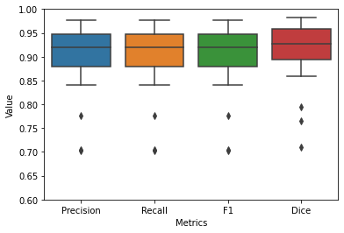

## Visualisation

### Lowest Dice Score

# pick the index for the lowest dice score  
min_ds_idx = np.argmin(ds_list)  
  
print("Binarised Segmentation Results:")  
imgs = [total_imgs[min_ds_idx], ori_mask[min_ds_idx], pred_mask[min_ds_idx]]  
captions = ['Gland Image', 'Masking', 'Predicted Mask']  
utils.plot_comparison(imgs, captions, n_col=len(imgs), figsize=(12, 12), cmap=None)  
  
print("Overlay Results:")  
ori_overlay_img = utils.overlay_boundary(utils.overlay_mask(total_imgs[min_ds_idx],   
 ori_mask[min_ds_idx], alpha=0.1,  
 colors=[(1.0, 0, 0)]), ori_mask[min_ds_idx],  
 color=(1.0,0,0))  
pred_overlay_img = utils.overlay_boundary(utils.overlay_mask(total_imgs[min_ds_idx],   
 pred_mask[min_ds_idx], alpha=0.1), pred_mask[min_ds_idx])  
imgs = [total_imgs[min_ds_idx], ori_overlay_img, pred_overlay_img]  
captions = ['Gland Image', 'Masking', 'Predicted Mask']  
utils.plot_comparison(imgs, captions, n_col=len(imgs), figsize=(12, 12), cmap=None)   
   
print("Hausdorff Distance:")  
legend_elements = [Line2D([0], [0], color='r', lw=3, label='Groundtruth'),  
 Line2D([0], [0], color='g', lw=3, label='Predicted')]  
ori_boundary_img = utils.overlay_boundary(total_imgs[min_ds_idx], ori_mask[min_ds_idx],  
 color=(1.0,0,0))  
# supervimposed predicted boundary on ori boundary   
pred_boundary_img = utils.overlay_boundary(ori_boundary_img, pred_mask[min_ds_idx])  
plt.figure(figsize=(12, 12))  
plt.imshow(pred_boundary_img)  
plt.legend(handles=legend_elements, loc='lower left')  
plt.show()  
print("Metric Results:")  
print("---------------")  
print("Precision: {:.2f}, Recall: {:.2f}, F1 Score:{:.2f}, Dice Score: {:.2f}, Hausdorff Distance:{}".format(p_list[min_ds_idx],   
 r_list[min_ds_idx],  
 f_list[min_ds_idx],  
 ds_list[min_ds_idx],  
 hd_list[min_ds_idx]))

Binarised Segmentation Results:

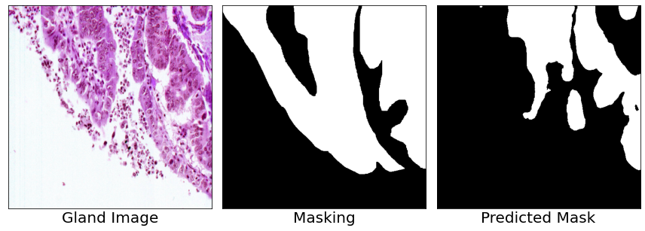

Overlay Results:

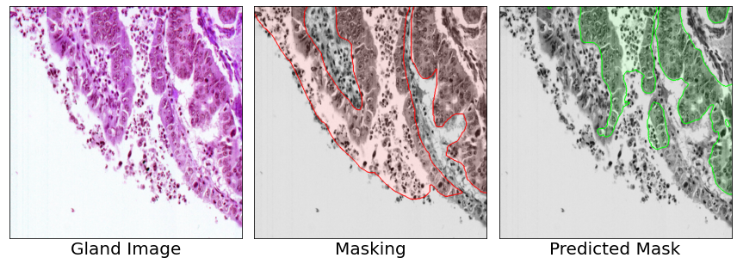

Hausdorff Distance:

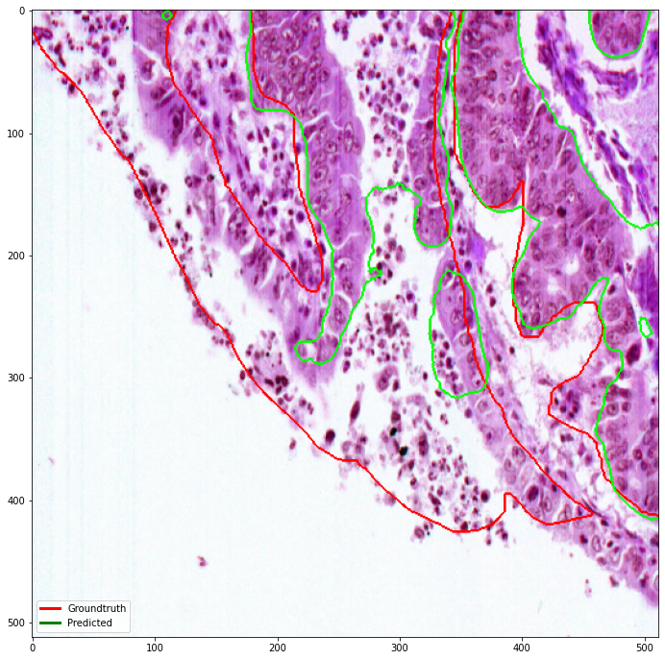

Metric Results:  
---------------  
Precision: 0.72, Recall: 0.72, F1 Score:0.72, Dice Score: 0.61, Hausdorff Distance:122.0245876862528

### Highest Dice Score

# pick the index for the lowest dice score  
max_ds_idx = np.argmax(ds_list)  
  
print("Binarised Segmentation Results:")  
imgs = [total_imgs[max_ds_idx], ori_mask[max_ds_idx], pred_mask[max_ds_idx]]  
captions = ['Gland Image', 'Masking', 'Predicted Mask']  
utils.plot_comparison(imgs, captions, n_col=len(imgs), figsize=(12, 12), cmap=None)  
  
print("Overlay Results:")  
ori_overlay_img = utils.overlay_boundary(utils.overlay_mask(total_imgs[max_ds_idx],   
 ori_mask[max_ds_idx], alpha=0.1,  
 colors=[(1.0, 0, 0)]), ori_mask[max_ds_idx],  
 color=(1.0,0,0))  
pred_overlay_img = utils.overlay_boundary(utils.overlay_mask(total_imgs[max_ds_idx],   
 pred_mask[max_ds_idx], alpha=0.1), pred_mask[max_ds_idx])  
imgs = [total_imgs[max_ds_idx], ori_overlay_img, pred_overlay_img]  
captions = ['Gland Image', 'Masking', 'Predicted Mask']  
utils.plot_comparison(imgs, captions, n_col=len(imgs), figsize=(12, 12), cmap=None)   
   
print("Hausdorff Distance:")  
legend_elements = [Line2D([0], [0], color='r', lw=3, label='Groundtruth'),  
 Line2D([0], [0], color='g', lw=3, label='Predicted')]  
ori_boundary_img = utils.overlay_boundary(total_imgs[max_ds_idx], ori_mask[max_ds_idx],  
 color=(1.0,0,0))  
# supervimposed predicted boundary on ori boundary   
pred_boundary_img = utils.overlay_boundary(ori_boundary_img, pred_mask[max_ds_idx])  
plt.figure(figsize=(12, 12))  
plt.imshow(pred_boundary_img)  
plt.legend(handles=legend_elements, loc='lower left')  
plt.show()  
  
print("Metric Results:")  
print("---------------")  
print("Precision: {:.2f}, Recall: {:.2f}, F1 Score:{:.2f}, Dice Score: {:.2f}, Hausdorff Distance:{}".format(p_list[max_ds_idx],   
 r_list[max_ds_idx],  
 f_list[max_ds_idx],  
 ds_list[max_ds_idx],  
 hd_list[max_ds_idx]))

Binarised Segmentation Results:

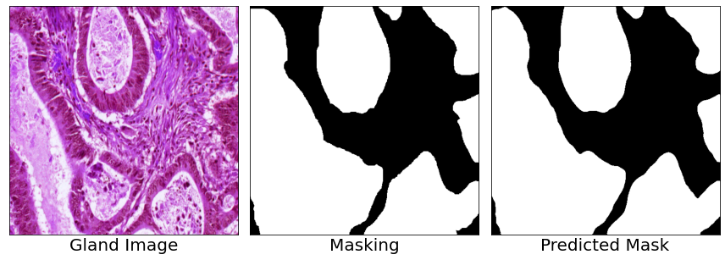

Overlay Results:

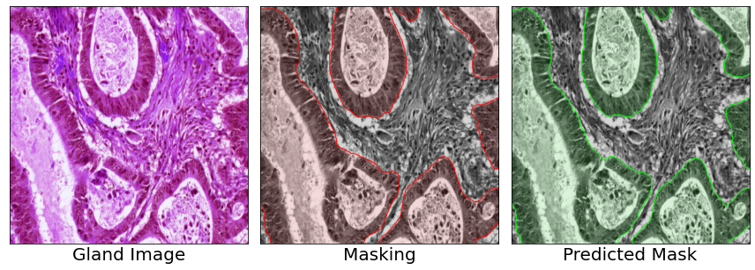

Hausdorff Distance:

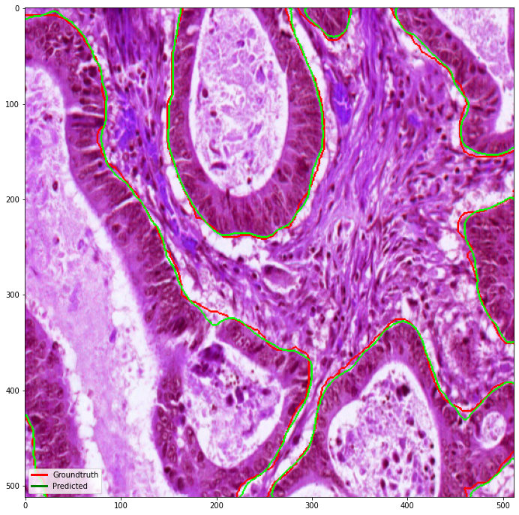

Metric Results:  
---------------  
Precision: 0.98, Recall: 0.98, F1 Score:0.98, Dice Score: 0.99, Hausdorff Distance:11.661903789690601

# Future Work

Gland-wise segmentation results using custom written code for evaluation seems too good to be true. The overall results is better than pixel-wise segmentation results and the results during the GlaS2015 challenge (paper: <https://www.researchgate.net/publication/301841306_Gland_Segmentation_in_Colon_Histology_Images_The_GlaS_Challenge_Contest>). This section serves as a demonstration on how binarised segmentatin results can be converted to gland-wise segmentation and the metrics to calculate gland-wise segmentation serves as future reference.

# convert binary segmentation to gland-level label by finding the intersection   
# between the original masking and the predicted masking, if overlap, the   
# area is assigned to the labels samed as the original masking, else => 0  
pred_multi = np.where((total_segs>0.) & (total_pred==1.0), total_segs, 0.0)

seg_color = utils.plot_labels_color(total_segs[1].astype('uint8'))  
pred_color = utils.plot_labels_color(pred_multi[1].astype('uint8'))  
imgs = [total_imgs[1], seg_color, pred_color]  
captions = ['Gland Image', 'Masking', 'Predicted Mask']  
utils.plot_comparison(imgs, captions, n_col=len(imgs), figsize=(12, 12), cmap=None)

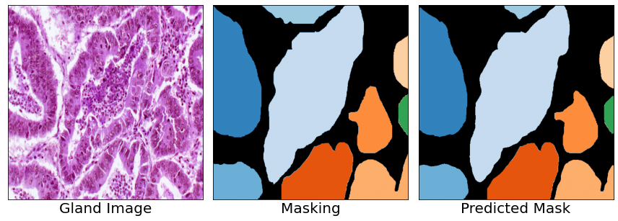

obj_ds_list = []  
obj_hd_list = []  
obj_f_list = []  
for i in range(len(pred_multi)):   
 obj_dice = metric.ObjectDice(pred_multi[i], total_segs[i])  
 obj_hd = metric.ObjectHausdorff(pred_multi[i], total_segs[i])  
 obj_f = metric.F1score(pred_multi[i], total_segs[i])  
 obj_ds_list.append(obj_dice)  
 obj_hd_list.append(obj_hd)  
 obj_f_list.append(obj_f)  
print("Object F1-score: {:.2f}".format(np.mean(obj_f_list)))  
print("Object Dice score: {:.2f}".format(np.mean(obj_ds_list)))  
print("Object Hausdorff Distance: {:.2f}".format(np.mean(obj_hd_list)))

Object F1-score: 0.93  
Object Dice score: 0.95  
Object Hausdorff Distance: 56.25

import warnings  
import numpy as np   
import matplotlib.pyplot as plt   
import utils  
import metric   
import torch   
import dataloader   
from batchgenerators.dataloading.multi_threaded_augmenter import MultiThreadedAugmenter  
import segmentation_models_pytorch as smp  
from torchsummary import summary  
import time  
import math   
import pandas as pd   
import wandb  
from tqdm import tqdm  
from torch import nn  
from sklearn.metrics import precision_recall_fscore_support, jaccard_score  
from scipy.spatial.distance import directed_hausdorff  
from matplotlib.lines import Line2D  
import seaborn as sns  
%matplotlib inline

# Hyperparameters

# load hyperparams  
batch_size = 16  
patch_size = (512, 512)  
encoder_model = 'resnet18'  
n_class = 1  
test_fol = 'testA_ds'  
weight_path = 'weights/best_weight.pth'

# Model Building

warnings.filterwarnings('ignore')  
tabular_data = pd.read_csv('data.csv')  
ds_dict = dataloader.get_split_fold(tabular_data)  
val_dl = dataloader.DataLoader(data=ds_dict[test_fol], batch_size=batch_size, patch_size=patch_size,  
 num_threads_in_multithreaded=1, seed_for_shuffle=5243,  
 return_incomplete=True, shuffle=False, infinite=False)  
# Get cpu or gpu device for training  
device = "cuda" if torch.cuda.is_available() else "cpu"  
# define model  
model = smp.Unet(encoder_name=encoder_model, decoder_use_batchnorm=True,  
 in_channels=3, classes=n_class).to(device)

The model choice is UNet architecture with trainable parameters of around 14 million.

summary(model, (3, 512, 512))

==========================================================================================  
Layer (type:depth-idx) Output Shape Param #  
==========================================================================================  
├─ResNetEncoder: 1-1 [-1, 3, 512, 512] --  
| └─Conv2d: 2-1 [-1, 64, 256, 256] 9,408  
| └─BatchNorm2d: 2-2 [-1, 64, 256, 256] 128  
| └─ReLU: 2-3 [-1, 64, 256, 256] --  
| └─MaxPool2d: 2-4 [-1, 64, 128, 128] --  
| └─Sequential: 2-5 [-1, 64, 128, 128] --  
| | └─BasicBlock: 3-1 [-1, 64, 128, 128] 73,984  
| | └─BasicBlock: 3-2 [-1, 64, 128, 128] 73,984  
| └─Sequential: 2-6 [-1, 128, 64, 64] --  
| | └─BasicBlock: 3-3 [-1, 128, 64, 64] 230,144  
| | └─BasicBlock: 3-4 [-1, 128, 64, 64] 295,424  
| └─Sequential: 2-7 [-1, 256, 32, 32] --  
| | └─BasicBlock: 3-5 [-1, 256, 32, 32] 919,040  
| | └─BasicBlock: 3-6 [-1, 256, 32, 32] 1,180,672  
| └─Sequential: 2-8 [-1, 512, 16, 16] --  
| | └─BasicBlock: 3-7 [-1, 512, 16, 16] 3,673,088  
| | └─BasicBlock: 3-8 [-1, 512, 16, 16] 4,720,640  
├─UnetDecoder: 1-2 [-1, 16, 512, 512] --  
| └─Identity: 2-9 [-1, 512, 16, 16] --  
| └─ModuleList: 2 [] --  
| | └─DecoderBlock: 3-9 [-1, 256, 32, 32] 2,360,320  
| | └─DecoderBlock: 3-10 [-1, 128, 64, 64] 590,336  
| | └─DecoderBlock: 3-11 [-1, 64, 128, 128] 147,712  
| | └─DecoderBlock: 3-12 [-1, 32, 256, 256] 46,208  
| | └─DecoderBlock: 3-13 [-1, 16, 512, 512] 6,976  
├─SegmentationHead: 1-3 [-1, 1, 512, 512] --  
| └─Conv2d: 2-10 [-1, 1, 512, 512] 145  
| └─Identity: 2-11 [-1, 1, 512, 512] --  
| └─Activation: 2-12 [-1, 1, 512, 512] --  
| | └─Identity: 3-14 [-1, 1, 512, 512] --  
==========================================================================================  
Total params: 14,328,209  
Trainable params: 14,328,209  
Non-trainable params: 0  
Total mult-adds (G): 9.46  
==========================================================================================  
Input size (MB): 3.00  
Forward/backward pass size (MB): 186.00  
Params size (MB): 54.66  
Estimated Total Size (MB): 243.66  
==========================================================================================

==========================================================================================  
Layer (type:depth-idx) Output Shape Param #  
==========================================================================================  
├─ResNetEncoder: 1-1 [-1, 3, 512, 512] --  
| └─Conv2d: 2-1 [-1, 64, 256, 256] 9,408  
| └─BatchNorm2d: 2-2 [-1, 64, 256, 256] 128  
| └─ReLU: 2-3 [-1, 64, 256, 256] --  
| └─MaxPool2d: 2-4 [-1, 64, 128, 128] --  
| └─Sequential: 2-5 [-1, 64, 128, 128] --  
| | └─BasicBlock: 3-1 [-1, 64, 128, 128] 73,984  
| | └─BasicBlock: 3-2 [-1, 64, 128, 128] 73,984  
| └─Sequential: 2-6 [-1, 128, 64, 64] --  
| | └─BasicBlock: 3-3 [-1, 128, 64, 64] 230,144  
| | └─BasicBlock: 3-4 [-1, 128, 64, 64] 295,424  
| └─Sequential: 2-7 [-1, 256, 32, 32] --  
| | └─BasicBlock: 3-5 [-1, 256, 32, 32] 919,040  
| | └─BasicBlock: 3-6 [-1, 256, 32, 32] 1,180,672  
| └─Sequential: 2-8 [-1, 512, 16, 16] --  
| | └─BasicBlock: 3-7 [-1, 512, 16, 16] 3,673,088  
| | └─BasicBlock: 3-8 [-1, 512, 16, 16] 4,720,640  
├─UnetDecoder: 1-2 [-1, 16, 512, 512] --  
| └─Identity: 2-9 [-1, 512, 16, 16] --  
| └─ModuleList: 2 [] --  
| | └─DecoderBlock: 3-9 [-1, 256, 32, 32] 2,360,320  
| | └─DecoderBlock: 3-10 [-1, 128, 64, 64] 590,336  
| | └─DecoderBlock: 3-11 [-1, 64, 128, 128] 147,712  
| | └─DecoderBlock: 3-12 [-1, 32, 256, 256] 46,208  
| | └─DecoderBlock: 3-13 [-1, 16, 512, 512] 6,976  
├─SegmentationHead: 1-3 [-1, 1, 512, 512] --  
| └─Conv2d: 2-10 [-1, 1, 512, 512] 145  
| └─Identity: 2-11 [-1, 1, 512, 512] --  
| └─Activation: 2-12 [-1, 1, 512, 512] --  
| | └─Identity: 3-14 [-1, 1, 512, 512] --  
==========================================================================================  
Total params: 14,328,209  
Trainable params: 14,328,209  
Non-trainable params: 0  
Total mult-adds (G): 9.46  
==========================================================================================  
Input size (MB): 3.00  
Forward/backward pass size (MB): 186.00  
Params size (MB): 54.66  
Estimated Total Size (MB): 243.66  
==========================================================================================

# Validation

The loss function used is dice loss and soft binary cross entropy (BCE + label smooting).

# xent = nn.BCELoss()  
dice_loss = smp.losses.DiceLoss(smp.losses.BINARY_MODE, from_logits=True)  
# label smoothing  
xent = smp.losses.SoftBCEWithLogitsLoss(smooth_factor=0.1)  
  
def custom_loss(pred, target):  
 xent_l = xent(pred, target)  
 dice_l = dice_loss(pred, target)  
 loss = xent_l + dice_l  
 return loss, xent_l, dice_l  
  
def test(model):  
 num_batches = math.ceil(len(ds_dict[test_fol]['img_npy']) / batch_size)  
 model.eval()  
 test_loss, correct = 0, 0  
 # no need back prop for testing set  
 batch_xent_l = []  
 batch_dice_l = []  
 batch_loss = []  
 imgs_list = []  
 segs_list = []  
 pred_list = []  
 segs_ori_list = []  
 print("Testing...")  
 with torch.no_grad():  
 for i in tqdm(range(num_batches)):  
 val_batch = next(val_dl)  
 imgs = val_batch['data']  
 segs = val_batch['seg']  
 segs_ori = segs   
 # normalization  
 imgs = utils.min_max_norm(imgs)  
 # binarisation  
 segs = np.where(segs > 0., 1.0, 0.).astype('float32')  
 segs = np.expand_dims(segs[:, 0, :, :], 1)  
 imgs, segs = torch.from_numpy(imgs).to(device), torch.from_numpy(segs).to(device)  
 # Compute loss  
 pred = model(imgs)  
 loss, xent_l, dice_l = custom_loss(pred, segs)  
 # batch losses  
 batch_xent_l.append(xent_l)  
 batch_dice_l.append(dice_l)  
 batch_loss.append(loss)  
 # accumulate outputs for each batch  
 imgs_list.append(imgs.cpu().detach().numpy())  
 segs_list.append(segs.cpu().detach().numpy())  
 pred_list.append(pred.cpu().detach().numpy())  
 segs_ori_list.append(segs_ori)  
 # apply sigmoid to masking  
 segs = nn.Sigmoid()(segs)  
 # taking the average along the batch  
 loss = torch.mean(torch.as_tensor(batch_loss)).item()  
 avg_xent_l = torch.mean(torch.as_tensor(batch_xent_l)).item()  
 avg_dice_l = torch.mean(torch.as_tensor(batch_dice_l)).item()  
 return {'loss': loss, 'xent_l': avg_xent_l, 'dice_l': avg_dice_l,  
 'imgs': imgs_list,  
 'segs': segs_list,  
 'pred': pred_list,  
 'segs_ori': segs_ori_list  
 }

model.load_state_dict(torch.load(weight_path))  
start = time.time()  
test_output = test(model)  
print("Runtime: {} s".format(time.time()-start))  
print("Total loss: {:.2f}, BCE: {:.2f}, Dice Loss: {:2f}".format(test_output['loss'],   
 test_output['xent_l'], test_output['dice_l']))

0%| | 0/4 [00:00<?, ?it/s]

Testing...

100%|██████████| 4/4 [00:02<00:00, 1.35it/s]

Runtime: 2.982046604156494 s  
Total loss: 0.59, BCE: 0.47, Dice Loss: 0.121558

# channel last for image plotting   
swap = (lambda x: np.einsum('bchw->bhwc', x))  
repeat_channel = (lambda x: np.repeat(x, 3, axis=-1))  
# stack the image along the batch axis   
total_segs = swap(np.vstack(tuple(test_output['segs_ori'])))  
total_imgs = swap(np.vstack(tuple(test_output['imgs'])))  
total_pred = repeat_channel(swap(np.where(np.vstack(tuple(test_output['pred']))>0.5, 1.0, 0.0)))

# sanity check for predicted output   
imgs = [total_imgs[0], total_segs[0], total_pred[0]]  
captions = ['Gland Image', 'Masking', 'Predicted Mask']  
utils.plot_comparison(imgs, captions, n_col=len(imgs), figsize=(12, 12), cmap=None)

Clipping input data to the valid range for imshow with RGB data ([0..1] for floats or [0..255] for integers).

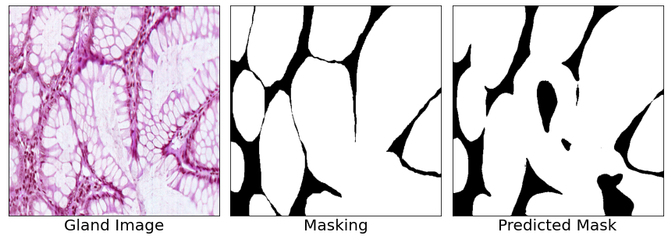

## Results

# Calculate the pixel-wise Precision, Recall, F1-score and Hausdorff Distance  
ori_mask = repeat_channel(swap(np.vstack(tuple(test_output['segs'])))) # binarised masking  
pred_mask = total_pred  
p_list = [] # precision list  
r_list = [] # recall list  
f_list = [] # f1 score list  
hd_list = [] # hausdorff list  
ds_list = [] # dice score list   
for i in range(len(ori_mask)):   
 p, r, f, _ = precision_recall_fscore_support(ori_mask[i][:,:,0].flatten().astype('uint8'),   
 pred_mask[i][:,:,0].flatten().astype('uint8'),  
 average='micro')  
 ds = metric.Dice(ori_mask[i][:,:,0].flatten().astype('uint8'),   
 pred_mask[i][:,:,0].flatten().astype('uint8'))  
 hd = metric.Hausdorff(ori_mask[i][:,:,0],   
 pred_mask[i][:,:,0])  
 p_list.append(p)  
 r_list.append(r)  
 f_list.append(f)  
 hd_list.append(hd)  
 ds_list.append(ds)  
  
print("Dataset: {}".format(test_fol))  
print('-'*20)  
print("Precision: {:.2f} ({:.2f})".format(np.mean(p_list), np.std(p_list)))  
print("Recall: {:.2f} ({:.2f})".format(np.mean(r_list), np.std(r_list)))  
print("F1-score: {:.2f} ({:.2f})".format(np.mean(f_list), np.std(p_list)))  
print("Dice score: {:.2f} ({:.2f})".format(np.mean(ds_list), np.std(ds_list)))  
print("Hausdorff Distance: {:.2f} ({:.2f})".format(np.mean(hd_list), np.std(hd_list)))

Dataset: testA_ds  
--------------------  
Precision: 0.93 (0.06)  
Recall: 0.93 (0.06)  
F1-score: 0.93 (0.06)  
Dice score: 0.92 (0.07)  
Hausdorff Distance: 83.35 (66.77)

# box plot   
data = {'Precision': p_list,  
 'Recall': r_list,  
 'F1': f_list,  
 'Dice': ds_list}  
metric_df = pd.DataFrame(data)  
metric_df = pd.melt(metric_df)  
# rename column   
metric_df.rename(columns = {'variable':'Metrics', 'value': 'Value'}, inplace = True)  
sns.boxplot(x="Metrics", y="Value", data=metric_df)  
plt.show()

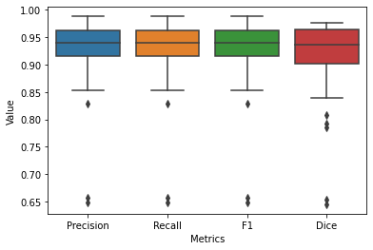

## Visualisation

### Lowest Dice Score

# pick the index for the lowest dice score  
min_ds_idx = np.argmin(ds_list)  
  
print("Binarised Segmentation Results:")  
imgs = [total_imgs[min_ds_idx], ori_mask[min_ds_idx], pred_mask[min_ds_idx]]  
captions = ['Gland Image', 'Masking', 'Predicted Mask']  
utils.plot_comparison(imgs, captions, n_col=len(imgs), figsize=(12, 12), cmap=None)  
  
print("Overlay Results:")  
ori_overlay_img = utils.overlay_boundary(utils.overlay_mask(total_imgs[min_ds_idx],   
 ori_mask[min_ds_idx], alpha=0.1,  
 colors=[(1.0, 0, 0)]), ori_mask[min_ds_idx],  
 color=(1.0,0,0))  
pred_overlay_img = utils.overlay_boundary(utils.overlay_mask(total_imgs[min_ds_idx],   
 pred_mask[min_ds_idx], alpha=0.1), pred_mask[min_ds_idx])  
imgs = [total_imgs[min_ds_idx], ori_overlay_img, pred_overlay_img]  
captions = ['Gland Image', 'Masking', 'Predicted Mask']  
utils.plot_comparison(imgs, captions, n_col=len(imgs), figsize=(12, 12), cmap=None)   
   
print("Hausdorff Distance:")  
legend_elements = [Line2D([0], [0], color='r', lw=3, label='Groundtruth'),  
 Line2D([0], [0], color='g', lw=3, label='Predicted')]  
ori_boundary_img = utils.overlay_boundary(total_imgs[min_ds_idx], ori_mask[min_ds_idx],  
 color=(1.0,0,0))  
# supervimposed predicted boundary on ori boundary   
pred_boundary_img = utils.overlay_boundary(ori_boundary_img, pred_mask[min_ds_idx])  
plt.figure(figsize=(12, 12))  
plt.imshow(pred_boundary_img)  
plt.legend(handles=legend_elements, loc='lower left')  
plt.show()  
print("Metric Results:")  
print("---------------")  
print("Precision: {:.2f}, Recall: {:.2f}, F1 Score:{:.2f}, Dice Score: {:.2f}, Hausdorff Distance:{}".format(p_list[min_ds_idx],   
 r_list[min_ds_idx],  
 f_list[min_ds_idx],  
 ds_list[min_ds_idx],  
 hd_list[min_ds_idx]))

Binarised Segmentation Results:

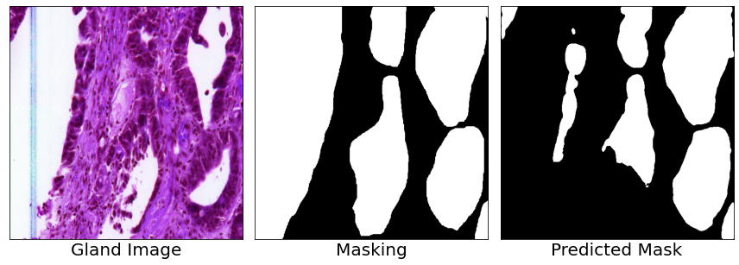

Overlay Results:

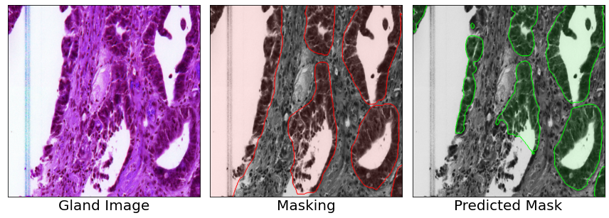

Hausdorff Distance:

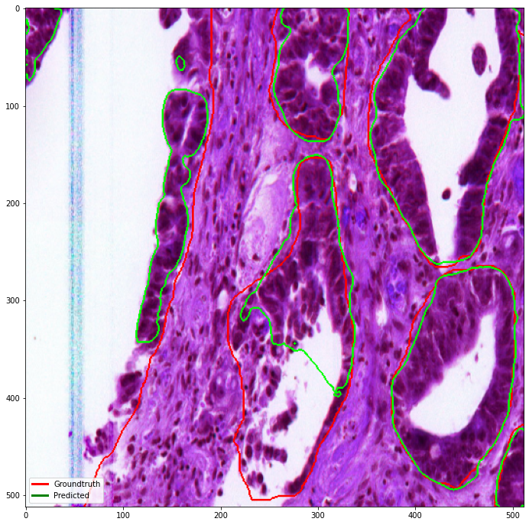

Metric Results:  
---------------  
Precision: 0.66, Recall: 0.66, F1 Score:0.66, Dice Score: 0.65, Hausdorff Distance:204.41624201613726

### Highest Dice Score

# pick the index for the lowest dice score  
max_ds_idx = np.argmax(ds_list)  
  
print("Binarised Segmentation Results:")  
imgs = [total_imgs[max_ds_idx], ori_mask[max_ds_idx], pred_mask[max_ds_idx]]  
captions = ['Gland Image', 'Masking', 'Predicted Mask']  
utils.plot_comparison(imgs, captions, n_col=len(imgs), figsize=(12, 12), cmap=None)  
  
print("Overlay Results:")  
ori_overlay_img = utils.overlay_boundary(utils.overlay_mask(total_imgs[max_ds_idx],   
 ori_mask[max_ds_idx], alpha=0.1,  
 colors=[(1.0, 0, 0)]), ori_mask[max_ds_idx],  
 color=(1.0,0,0))  
pred_overlay_img = utils.overlay_boundary(utils.overlay_mask(total_imgs[max_ds_idx],   
 pred_mask[max_ds_idx], alpha=0.1), pred_mask[max_ds_idx])  
imgs = [total_imgs[max_ds_idx], ori_overlay_img, pred_overlay_img]  
captions = ['Gland Image', 'Masking', 'Predicted Mask']  
utils.plot_comparison(imgs, captions, n_col=len(imgs), figsize=(12, 12), cmap=None)   
   
print("Hausdorff Distance:")  
legend_elements = [Line2D([0], [0], color='r', lw=3, label='Groundtruth'),  
 Line2D([0], [0], color='g', lw=3, label='Predicted')]  
ori_boundary_img = utils.overlay_boundary(total_imgs[max_ds_idx], ori_mask[max_ds_idx],  
 color=(1.0,0,0))  
# supervimposed predicted boundary on ori boundary   
pred_boundary_img = utils.overlay_boundary(ori_boundary_img, pred_mask[max_ds_idx])  
plt.figure(figsize=(12, 12))  
plt.imshow(pred_boundary_img)  
plt.legend(handles=legend_elements, loc='lower left')  
plt.show()  
  
print("Metric Results:")  
print("---------------")  
print("Precision: {:.2f}, Recall: {:.2f}, F1 Score:{:.2f}, Dice Score: {:.2f}, Hausdorff Distance:{}".format(p_list[max_ds_idx],   
 r_list[max_ds_idx],  
 f_list[max_ds_idx],  
 ds_list[max_ds_idx],  
 hd_list[max_ds_idx]))

Binarised Segmentation Results:

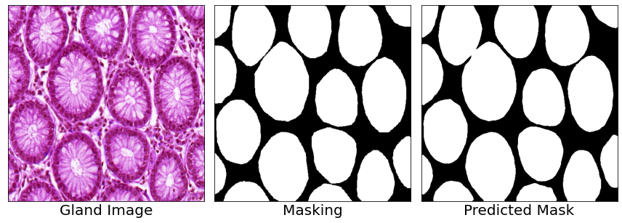

Overlay Results:

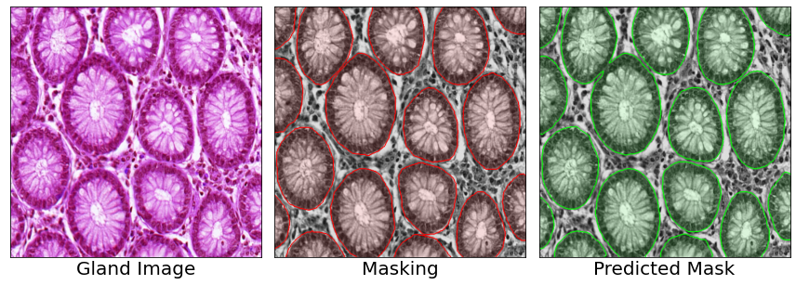

Hausdorff Distance:

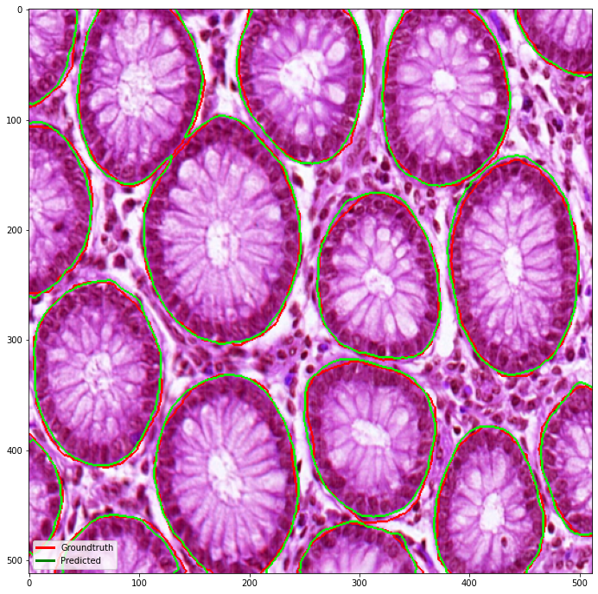

Metric Results:  
---------------  
Precision: 0.97, Recall: 0.97, F1 Score:0.97, Dice Score: 0.98, Hausdorff Distance:7.280109889280518

# Future Work

Gland-wise segmentation results using custom written code for evaluation seems too good to be true. The overall results is better than pixel-wise segmentation results and the results during the GlaS2015 challenge (paper: <https://www.researchgate.net/publication/301841306_Gland_Segmentation_in_Colon_Histology_Images_The_GlaS_Challenge_Contest>). This section serves as a demonstration on how binarised segmentatin results can be converted to gland-wise segmentation and the metrics to calculate gland-wise segmentation serves as future reference.

# convert binary segmentation to gland-level label by finding the intersection   
# between the original masking and the predicted masking, if overlap, the   
# area is assigned to the labels samed as the original masking, else => 0  
pred_multi = np.where((total_segs>0.) & (total_pred==1.0), total_segs, 0.0)

seg_color = utils.plot_labels_color(total_segs[max_ds_idx].astype('uint8'))  
pred_color = utils.plot_labels_color(pred_multi[max_ds_idx].astype('uint8'))  
imgs = [total_imgs[max_ds_idx], seg_color, pred_color]  
captions = ['Gland Image', 'Masking', 'Predicted Mask']  
utils.plot_comparison(imgs, captions, n_col=len(imgs), figsize=(12, 12), cmap=None)

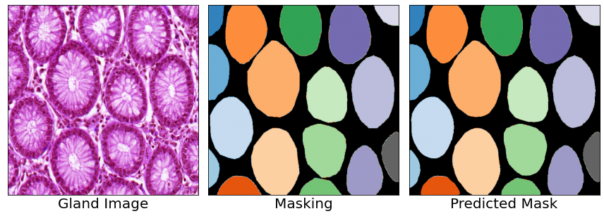

obj_ds_list = []  
obj_hd_list = []  
obj_f_list = []  
for i in range(len(pred_multi)):   
 obj_dice = metric.ObjectDice(pred_multi[i], total_segs[i])  
 obj_hd = metric.ObjectHausdorff(pred_multi[i], total_segs[i])  
 obj_f = metric.F1score(pred_multi[i], total_segs[i])  
 obj_ds_list.append(obj_dice)  
 obj_hd_list.append(obj_hd)  
 obj_f_list.append(obj_f)  
print("Object F1-score: {:.2f}".format(np.mean(obj_f_list)))  
print("Object Dice score: {:.2f}".format(np.mean(obj_ds_list)))  
print("Object Hausdorff Distance: {:.2f}".format(np.mean(obj_hd_list)))

Object F1-score: 0.95  
Object Dice score: 0.95  
Object Hausdorff Distance: 71.35

import numpy as np import matplotlib.pyplot as plt from skimage import color from skimage import segmentation

def plot_comparison(input_img, caption=None, plot=True, save_path=None, save_name=None, save_as=‘png’, save_dpi=300, captions_font = 20, n_row=1, n_col=2, figsize=(5, 5), cmap=‘gray’): ’’’ Plot comparison of multiple image but only in column wise! :param input_img: Input image list :param caption: Input caption list :param save_path: Path to save plot :param save_name: Name to be save for plot :param: save_as: plot save extension, ‘png’ by DEFAULT :param n_row: Number of row is 1 by DEFAULT :param n_col: Number of columns :param figsize: Figure size during plotting (5,5) by DEFAULT :return: Plot of (n_row, n_col) ’’’ print() if caption is not None: assert len(caption) == len(input_img), “Caption length and input image length does not match” assert len(input_img) == n_col, “Error of input images or number of columns!”

fig, axes = plt.subplots(n_row, n_col, figsize=figsize)  
fig.subplots_adjust(hspace=0.4, wspace=0.4, right=0.7)  
  
for i in range(n_col):  
 axes[i].imshow(np.squeeze(input_img[i]), cmap=cmap)  
 if caption is not None:  
 axes[i].set_xlabel(caption[i], fontsize=captions_font)  
 axes[i].set_xticks([])  
 axes[i].set_yticks([])  
  
plt.tight_layout()  
if save_path is not None:  
 plt.savefig(save_path+'{}.{}'.format(save_name, save_as), save_dpi=save_dpi)  
if plot:  
 plt.show()  
else:  
 return fig

def plot_hist(inp_img, titles, n_row=1, n_col=2, n_bin=20, ranges=[0, 1], figsize=(5, 5)): ’’’ Plot histogram side by side :param inp_img: Input image stacks as list :param titles: Input titles as list :param n_row: Number of row by DEFAULT 1 :param n_col: Number of columns by DEFAULT 2 :param n_bin: Number of bins by DEFAULT 20 :param ranges: Range of pixel values by DEFAULT [0,1] :param figsize: Figure size while plotting by DEFAULT (5,5) :return: Plot of histograms ’’’ assert len(titles) == len(inp_img), “Caption length and input image length does not match” assert len(inp_img) == n_col, “Error of input images or number of columns!”

fig, axes = plt.subplots(n_row, n_col, figsize=figsize)  
fig.subplots_adjust(hspace=0.4, wspace=0.4, right=0.7)  
  
for i in range(n_col):  
 inp = np.squeeze(inp_img[i])  
 axes[i].hist(inp.ravel(), n_bin, ranges)  
 axes[i].set_title(titles[i])  
 axes[i].set_xlabel('Pixel Value')  
 axes[i].set_ylabel('Frequency')  
  
plt.tight_layout()  
plt.show()

def overlay_mask(image, mask, colors=[(0, 1.0, 0)], alpha=0.12): ““” Helper function to plot overlay image segmentation of the original image @param image: input image @param mask: segmentation mask @param colors: color spectrum of type (R,G,B) @param alpha: masking opacity @return: overlay image ““” # normalize image if np.max(image)>1.0: image = image/255.0 # gray scale image if mask.ndim is 3: mask = mask[:,:,0] mask_image = color.label2rgb(mask, image, colors=colors, alpha=alpha, bg_label = 0) return mask_image

def overlay_boundary(image, mask, color=(0, 1.0, 0), mode=‘thick’): ““” Helper function to plot overlay image segmentation boundary of the original image @param image: input image @param mask: segmentation mask @param color: color spectrum of type (R,G,B) @param mode: mode of the boundary line @return: overlay image with segmented contour ““” # normalize image if np.max(image)>1.0: image = image/255.0 if mask.ndim is 3: mask = mask[:,:,0] boundary_image = segmentation.mark_boundaries(image, mask, color = color, mode=mode) return boundary_image

def plot_labels_color(label_im, cmap=‘tab20c’): ““” Helper function to visualize the gland level masking by looping through the color map (cmap) defined in matplotlib @param label_im: annotated image @param cmap: cmap defined in the documentation of matplotlib @return: gland level segmentation with color based on cmap ““” # Construct a colour image to superimpose color_mask = np.zeros(label_im.shape) get_cmap = plt.cm.get_cmap(cmap) # Loop through the cmap for each color with it’s associated labels for i in range(np.max(label_im)): color_mask[label_im[:, :, 0] == i + 1] = list(get_cmap(i))[:-1]

return color_mask

def min_max_norm(img, axis=(1, 2)): ““” Channel-wise Min max normalization for images with input [batch size, slices, width, channel] @param img: Input image of 4D array @return: Min max norm of the image per channel ““” inp_shape = img.shape img_min = np.broadcast_to(img.min(axis=axis, keepdims=True), inp_shape) img_max = np.broadcast_to(img.max(axis=axis, keepdims=True), inp_shape) x = (img-img_min)/(img_max-img_min+float(1e-18)) return x

1. **总结（心得体会）**

导入必要的模块，建立训练和验证数据加载器，初始化UNet模型及其优化器，并定义模型的损失函数。定义了一个定制的训练函数，该函数通过训练集运行模型，计算损失，并使用反向传播更新模型的权重。类似地，定义了一个测试函数来计算测试集上的损失，而不更新模型的权重。

上面的Python脚本是进行腺体分割。首先我们导入必要的库，如PyTorch、NumPy和Pandas。之后引入一些自定义模块，如utils、dataloader和segmentation_models_pytorch。

初始化权重和偏差(wandb)项目，并根据位于config/config. YAML中的YAML配置文件配置一些参数。YAML文件用于配置模型超参数，如学习率、epoch数、批处理大小、补丁大小和编码器模型架构。

定义自定义损失函数以及训练和测试函数。训练函数使用训练数据集训练模型，而测试函数在验证数据集上评估训练后的模型。

使用来自segmentation_models_pytorch的Unet架构，这是用于图像分割任务的类似于u - net的架构。该模型采用带标记平滑的二元交叉熵损失函数和一个骰子损失函数。用于训练的优化器在YAML配置文件中指定，学习率也由配置文件设置。

训练函数计算损失，反向传播，并使用指定的优化器更新模型的权重。测试函数通过计算损失来评估验证数据集上的训练模型，并且在评估期间不执行反向传播或权重更新。

使用batchgenerators库中的multithreadadaugmenter类使用多线程数据增强。这个库为图像分割任务提供了一些有用的数据增强函数和实用程序。

最后，将训练函数的一些重要输出保存为numpy数组，以供进一步分析，例如损失、二进制交叉熵损失、骰子损失以及预测的和真实的分割掩码。